**Analysis on Cricket(IPL) Dataset**



-Akshay Ankush Kapare

[Akshay08@bu.edu](mailto:Akshay08@bu.edu)

BU ID: U50485521

MET CS 779 Project

Table of Contents

1. Introduction 2

2. Tools 2

3. Datasets 3

4. ERD 4

5. Design Implementation for IPL dataset 6

1) Preprocessing for CSV files 6

2) Table creation in MySql server 11

3) Connecting SQL to Python and adding Data to SQL database 14

4) User Define Functions 18

5) Analysis on IPL database 23

6. Design Implementation for IPL dataset with Weather data 26

1) Preprocessing for CSV files 26

2) Analysis on Match w.r.t Weather 30

7. References 32

# Introduction

My project is about Analysis of Cricket Tournament called IPL played in INIDA from year 2008 to 2017.I am majorly focusing on two parts IPL Tournament history such as every match Information and Season information and Weather analysis of each match played in Delhi from 2013 to 2016.

In my first part I have decided to achieve a goal of getting match information by sending match ID to the user define function and by sending year user define function and fetch season info. Which I have explained in design process. Along with this I am also presenting analysis using Power BI. To achieve this goal, I have taken data set form Kaggle. Using python, I have preprocessed the data and after that using Python libraries I have connected my SQL server to notebook and added all that there, Once I have all data in my database I have written two user define functions to display match information and season information.

In second part I have done Weather analysis of each match played in Delhi from 2013 to 2016 based on daily average wind speed, humidity, pressure, temperature. For this I used python to preprocess my data and analysis is done using Power BI.

# Tools

## 1. Jupyter Notebook

* Jupyter Notebook is compatible with Python.
* As python is easy language to get data from CSV and preprocess on the data using Pandas function.
* we can connect our database to notebook and add data directly using python commands.
* We can Run code line by Run which makes code easy to debug.

## 2. MS SQL server Management Studio

* Easy to create Database.
* Compatible with writing user define function and debugging is easy.

## 3. Power BI

* We can easily load CSV and get Data.
* Easy to connect with Sql Server and fetch data from Database
* By using Columns we can easily represent data in Graphical format

# Datasets

## 1. IPL dataset

In this Data set I have total 6 CSV files as follows:

1. Team

Team CSV file contain all the team names which are played or Playing in IPL till now

1. Match

Match CSV has information about match ID, Match Date, winning team man of the match, toss winner etc.

1. Player

Player csv contain all the data about player name, data of birth and players batting and bowling skills

1. Player match:

Player match csv contain data about which player played in which match

1. Ball by ball

Ball-by-Ball csv contain data about every single ball bowled form year 2008 to 2017 such as run scored, wickets taken or now bowler and batsman.

1. Team winning

This csv has information about

## 2. Weather Dataset

Weather dataset contain information about daily average wind speed, humidity, temperature, pressure of Delhi city in India form 2013 to 2016

.

# ERD

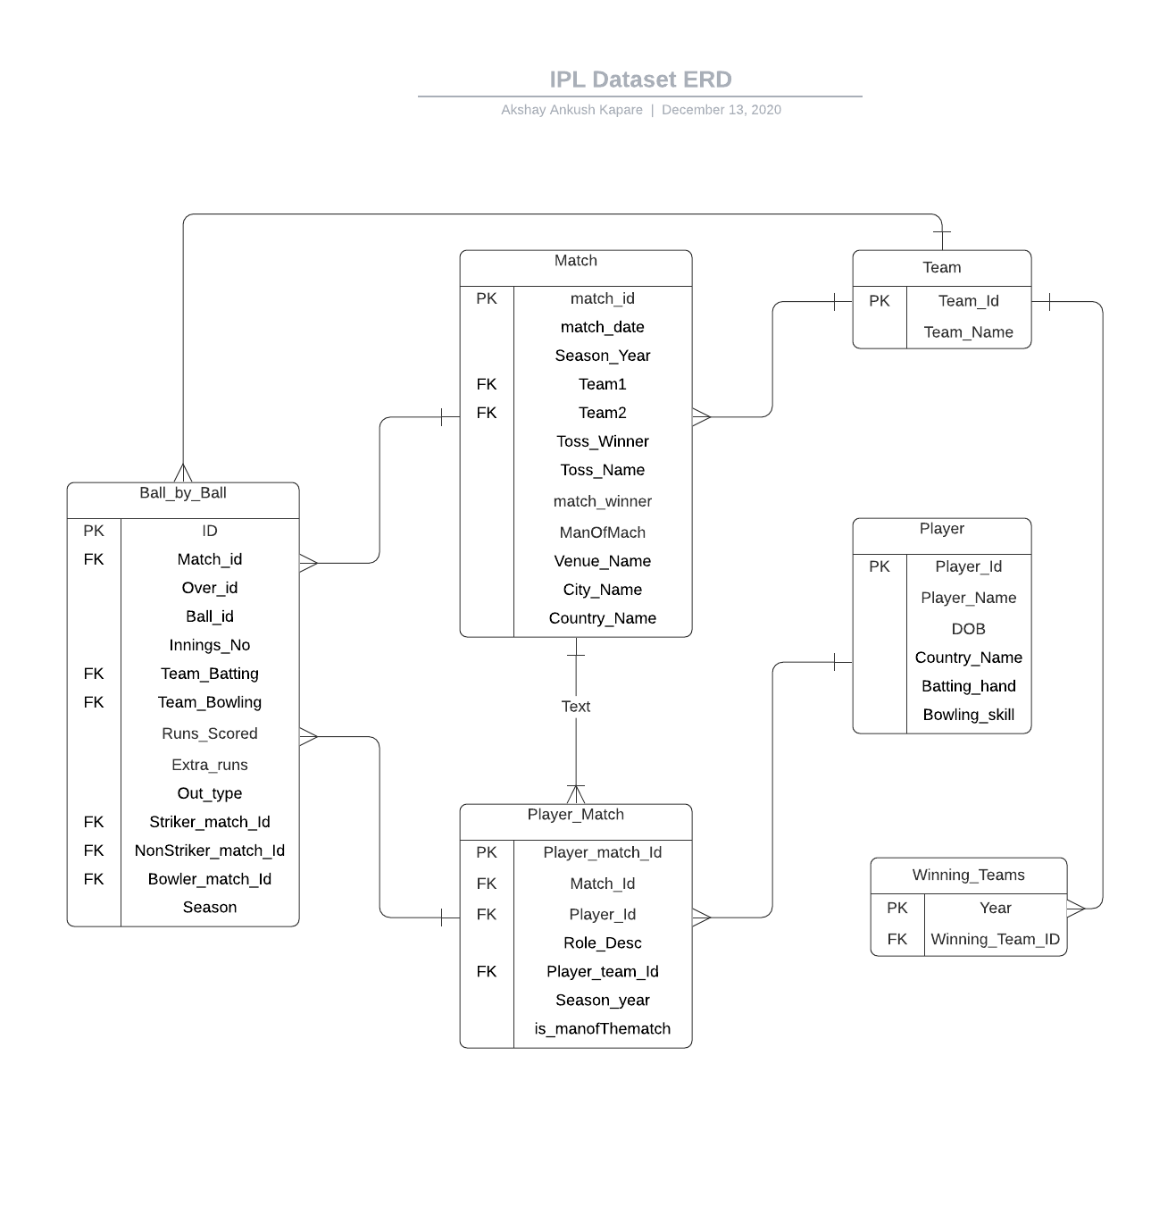

## 1. Team Table

Team table contain information about Team id and team Name

## 2. Winning team Table

This table has information about on which year which team won the tournament

## 3. Player Table

Player table contain information about Player Id, Name of the player, DOB, Players Country name, and players batting and bowling skills

## 4. Player Match Table

This table has information about which player played for which match, Team id for which he played, Role of that player such as Captain, Wicketkeeper or just player (either filer or bowler or batsman) Which match her got man on the match award

## 5. Match Table

Match table has details about Match ID, date, Teams information, Winning team, man of the match and Location information

## 6. Ball by ball table

Ball-by-Ball table contain data about every single ball bowled form year 2008 to 2017. This table has ID n match ID, ball ID (Each over will have 6 ball or more if extra balls bowled) we can say ball ID or Ball number, Over ID (each Team will face 20 overs) , batting team id, bowling team ID , Run scored per ball, Extra run for that ball, Out type, ID for batsman , ID for the bowler.

# Design Implementation for IPL dataset

## 1. Preprocessing for CSV files

1. Following Library used to preprocess the data and to connect MS SQL database to pythonI have used Pandas library to work on all the CSV files, I have converted them to data frame and after that preprocessing is done on each DF and made to ready to add to SQL serverThe pyodbc is library is used to connect python with MS Sql server to add data in database using python commands.

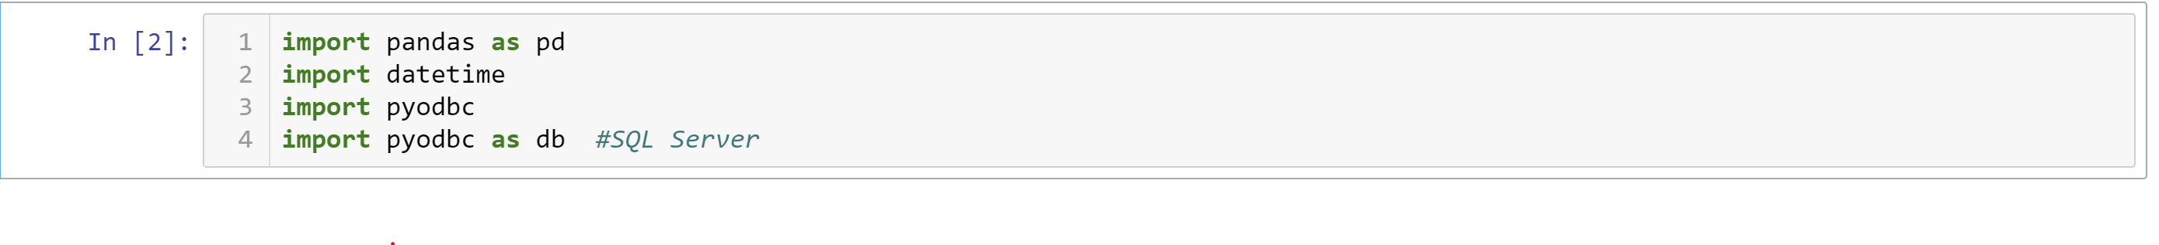

1. Loading Team CSV and preprocessing the data

For Team details CSV after converting to DF I have remove all the unwanted columns and set it to add to database which I have created in MS sql server. (IPL database)

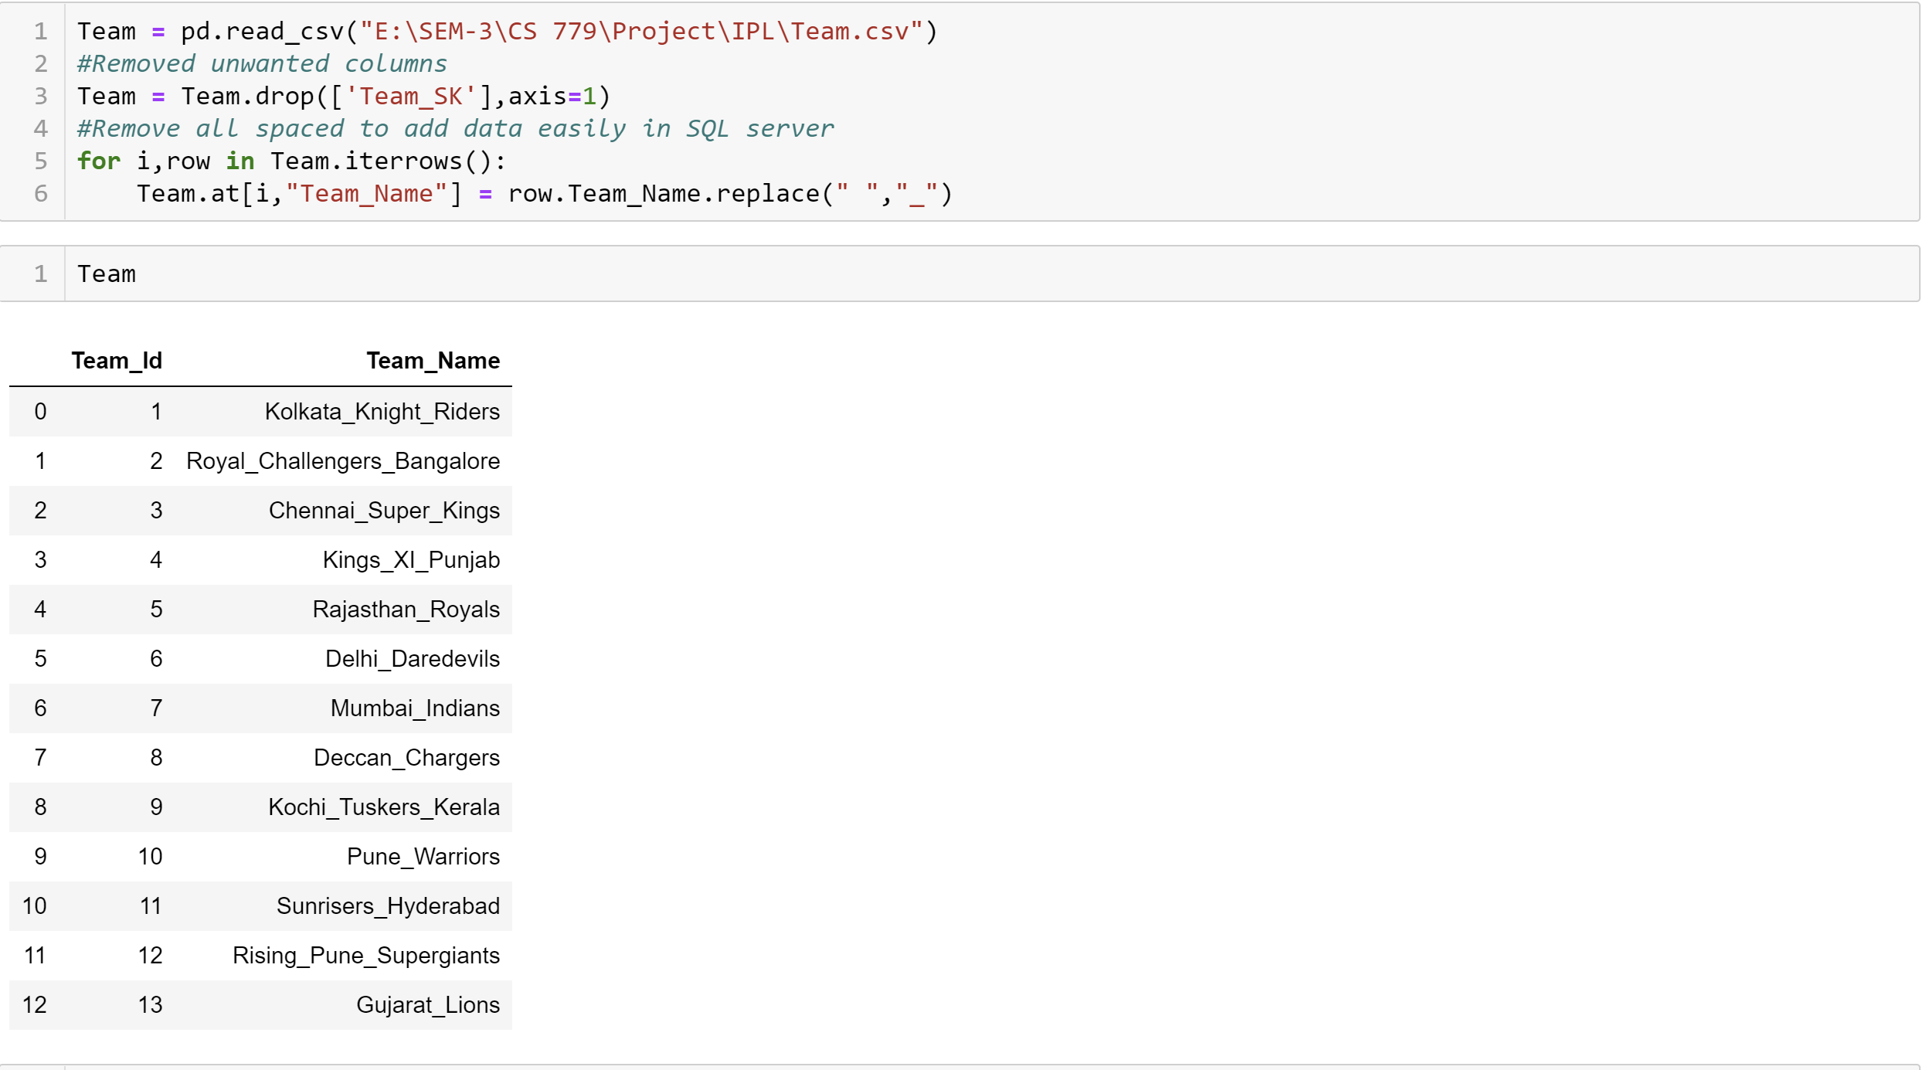

1. Loading Player CSV and preprocessing the data

For Player CSV also first converted to DF and after that I removed all unwanted space bars and blank spaces to make it easy to add to Database.

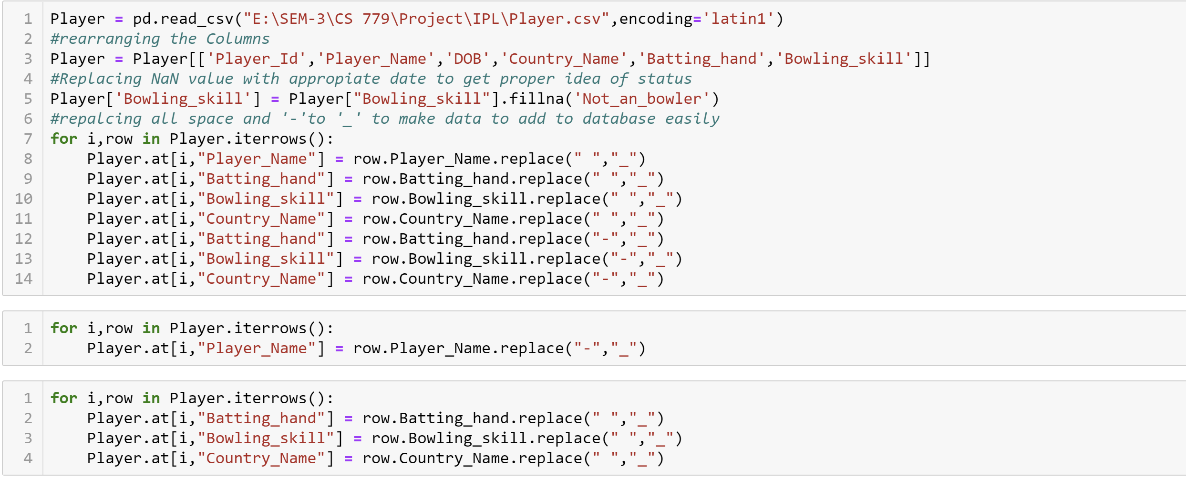

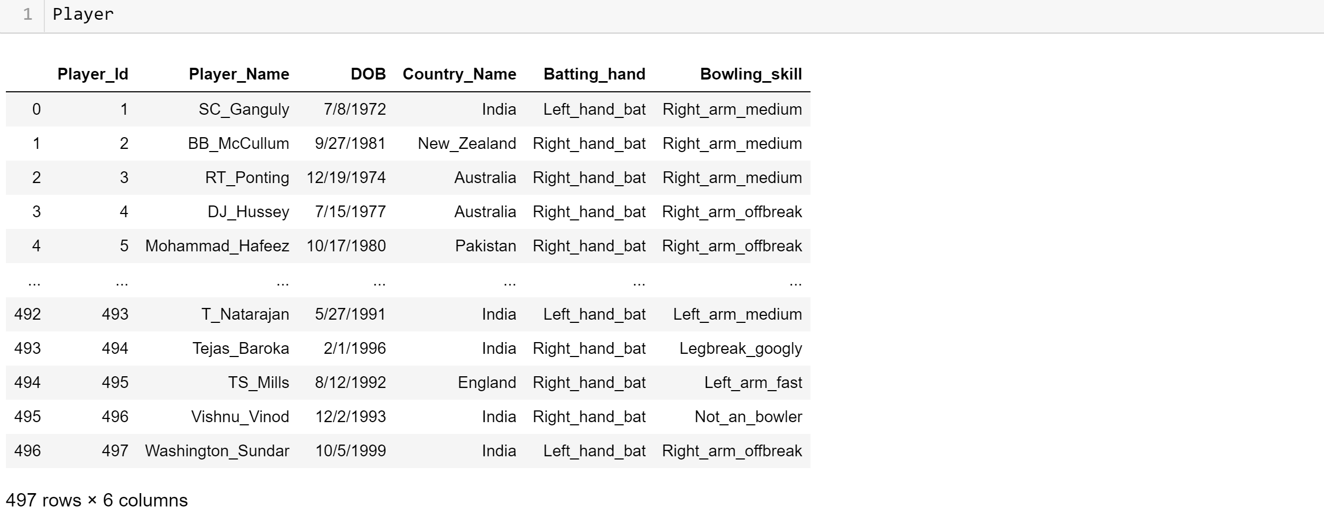

1. Loading Match CSV and preprocessing the data

After converting Match CSV to DF I have filled all NA values to specific values according to columns which helped me to display data in proper format for my user define function.

Here I used ‘map’ function in python to set all Team names to Team ID , basically map function used to set it as foreign key reference.

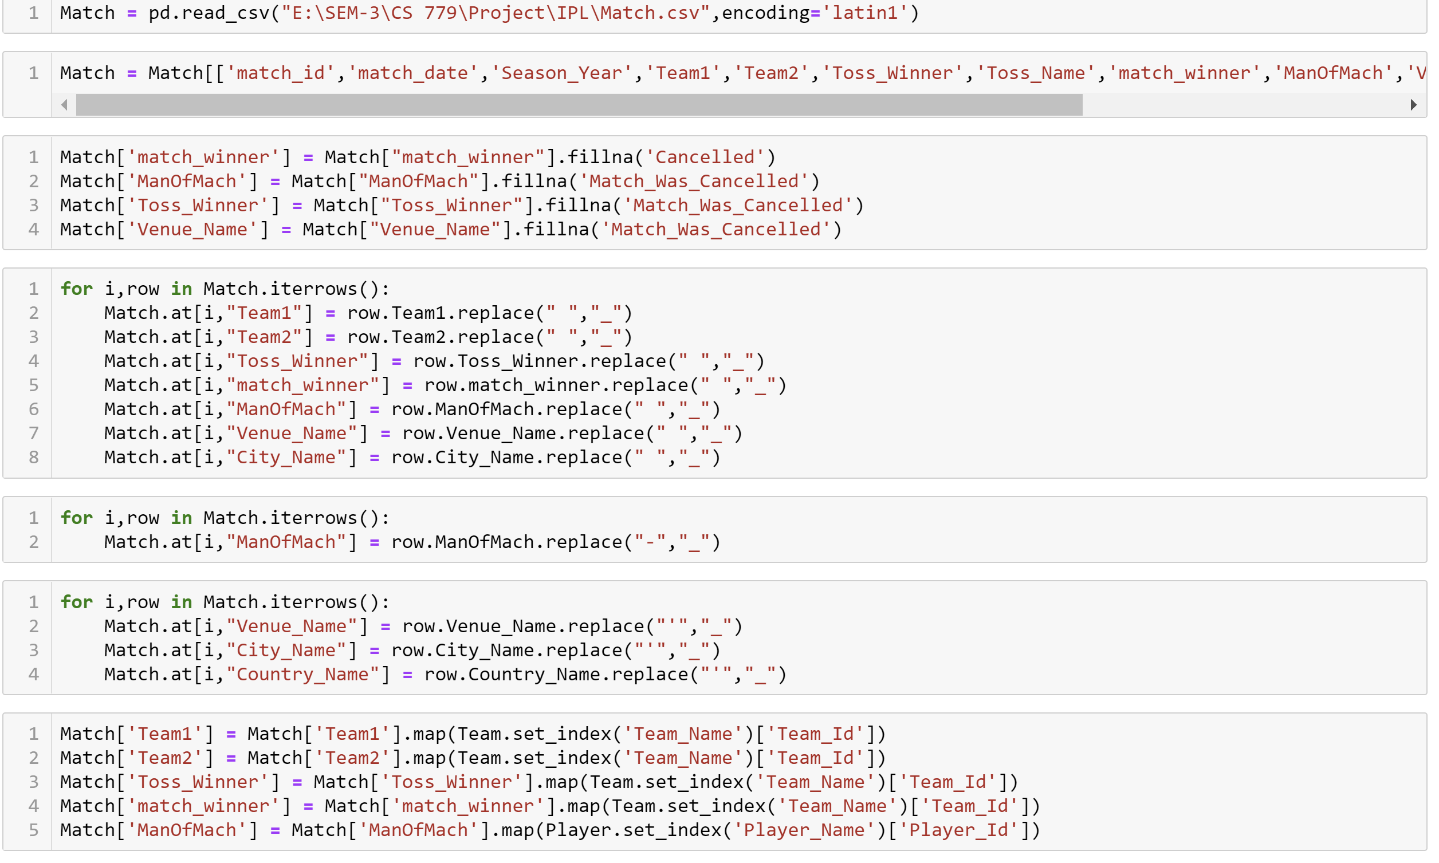

Converted some data type to INT as it was displaying decimal as team ID.

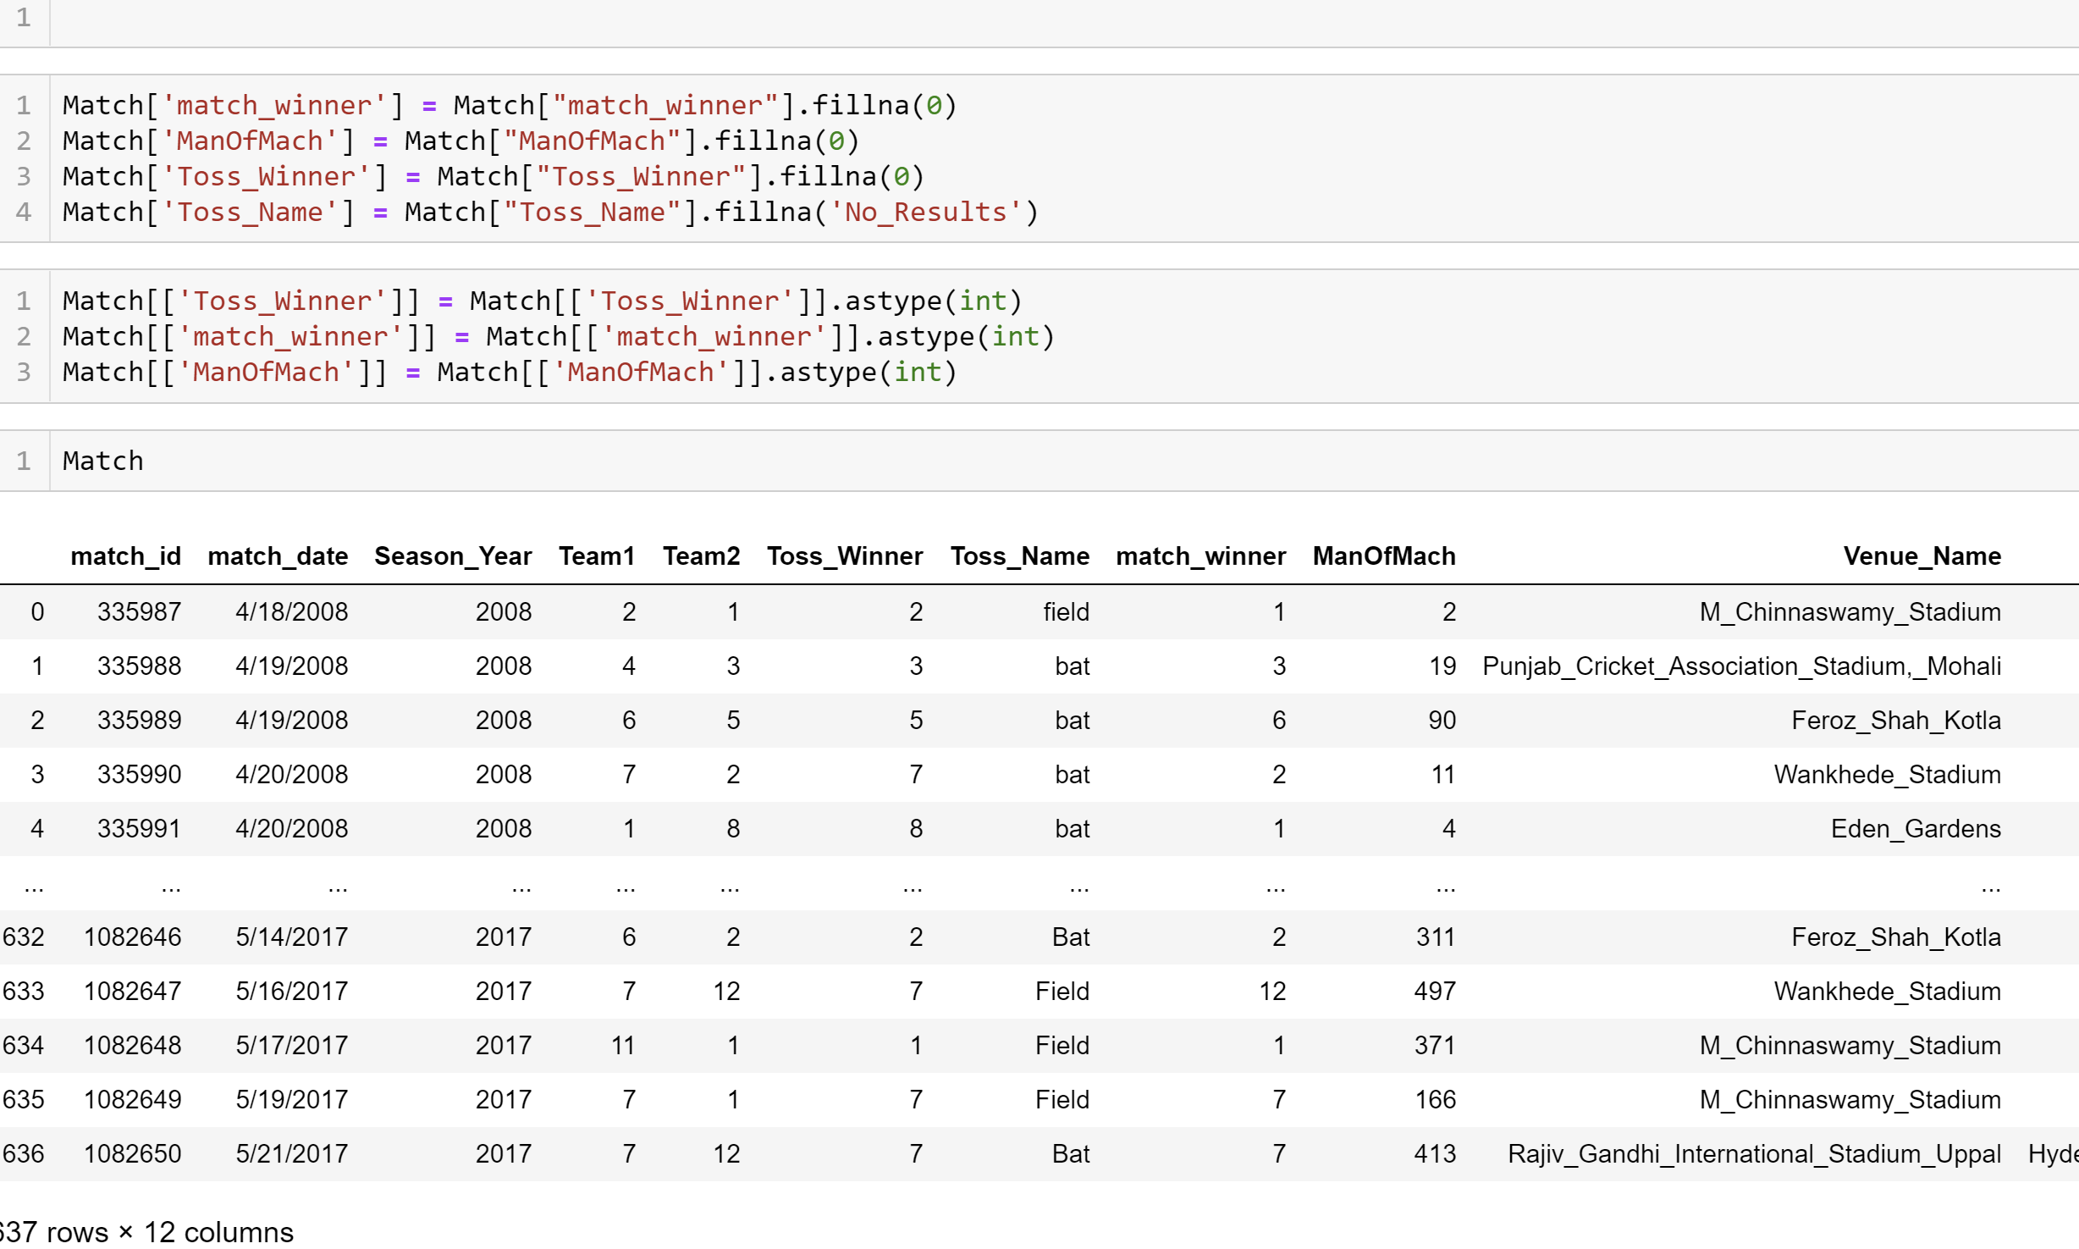

1. Loading Player Match CSV and preprocessing the data

For player CSV first its converted to df and I have taken only those columns which are used to get a data

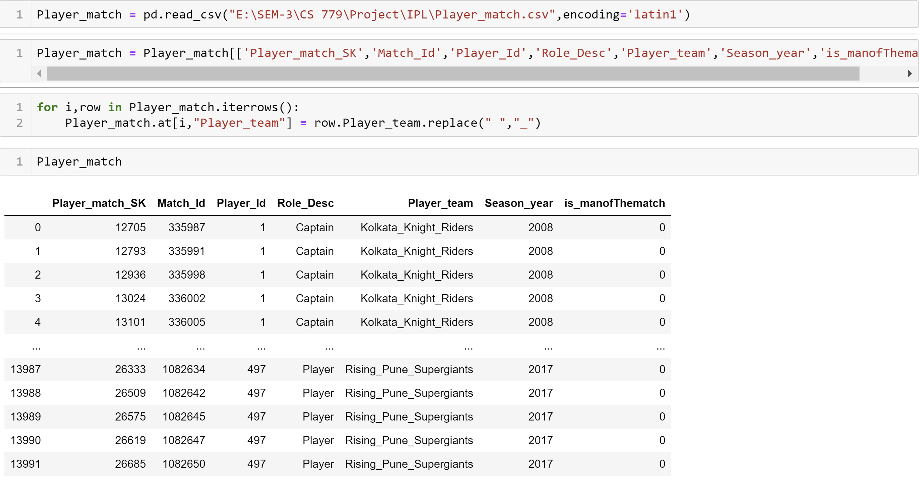

1. Loading Ball by Ball CSV and preprocessing the data

For ball-by-ball data I have replaced Team Name with ID and removed all the extra space between any word which helps me to add data to database.

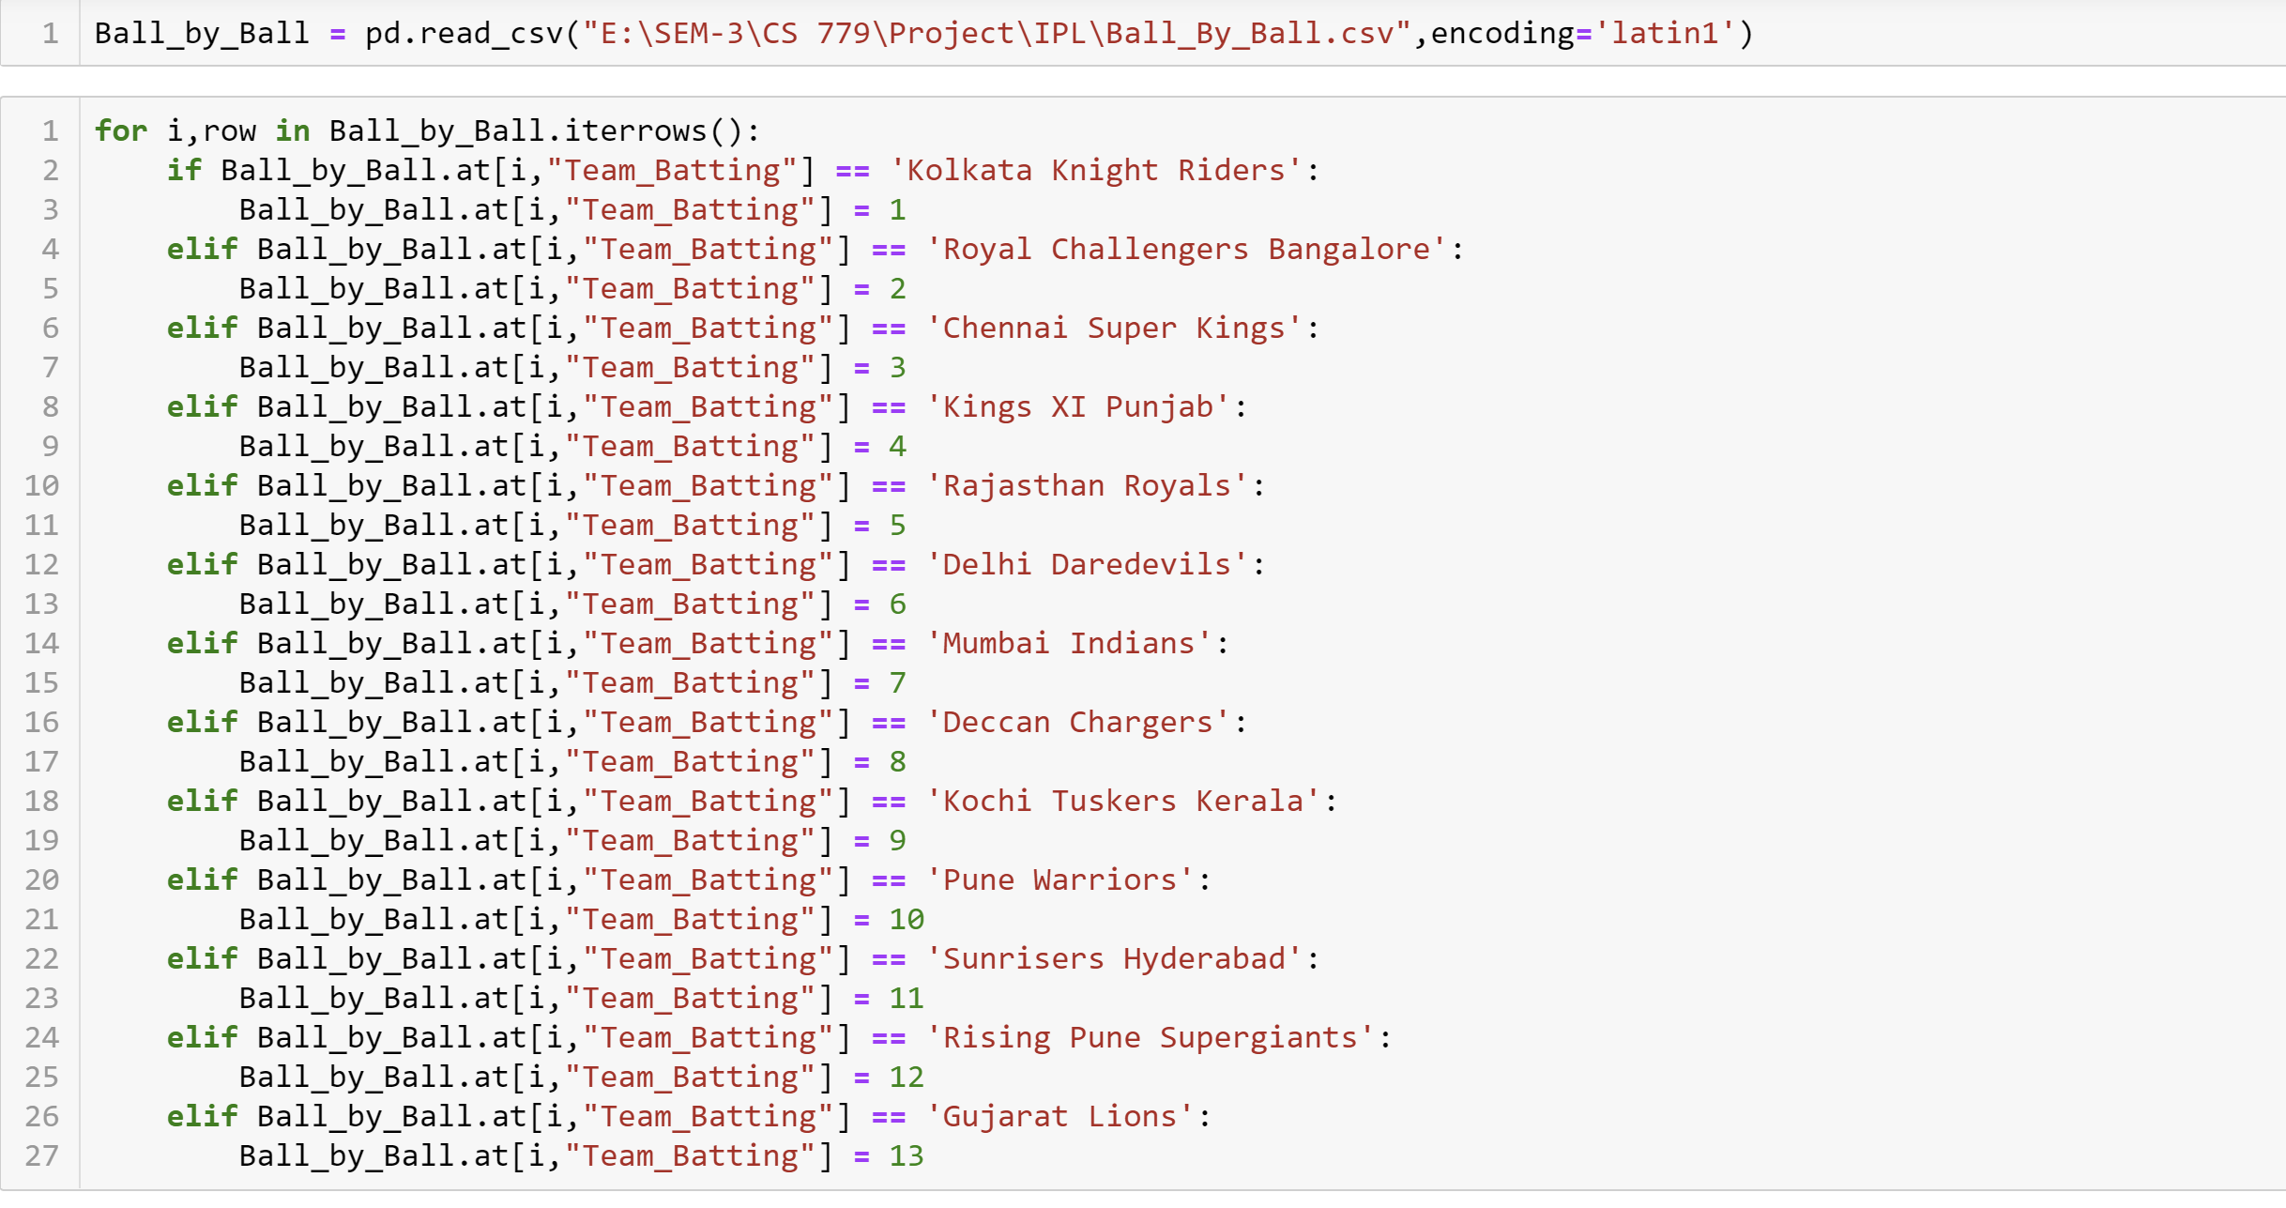

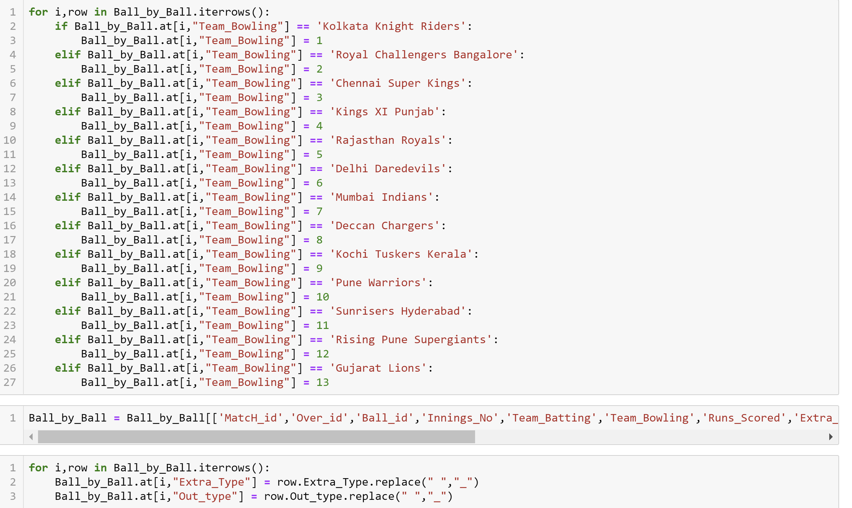

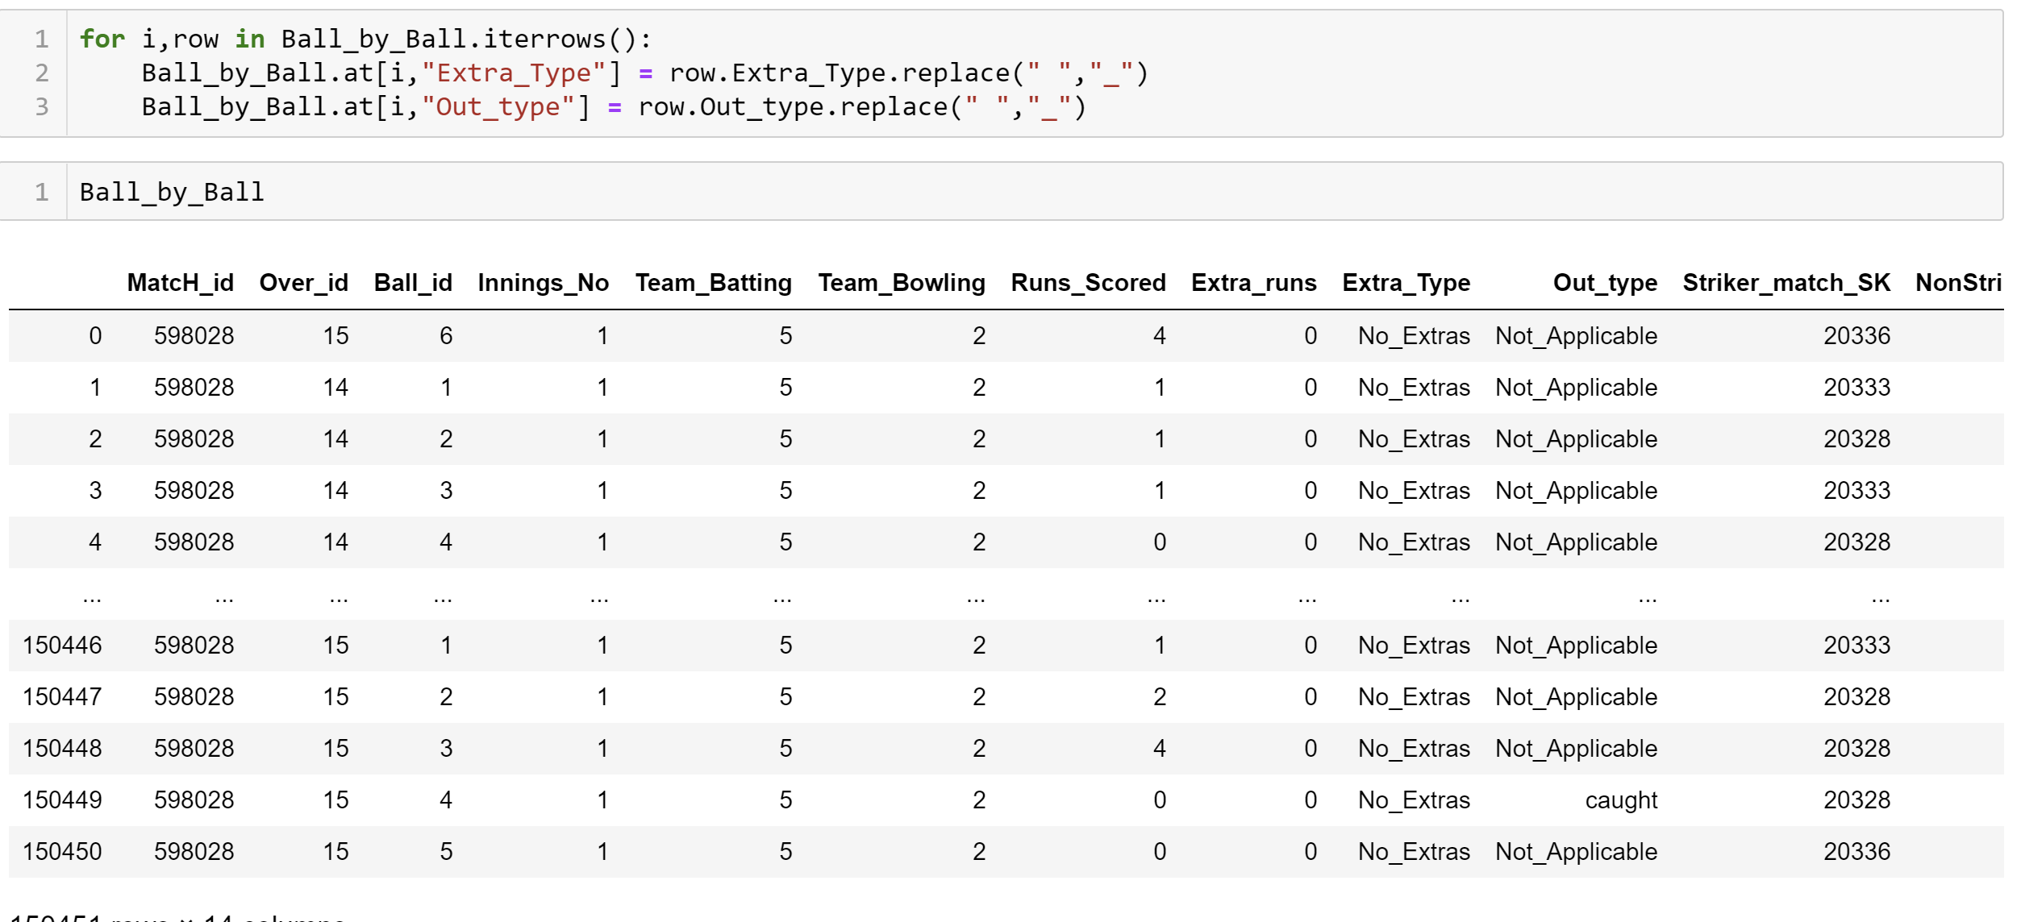

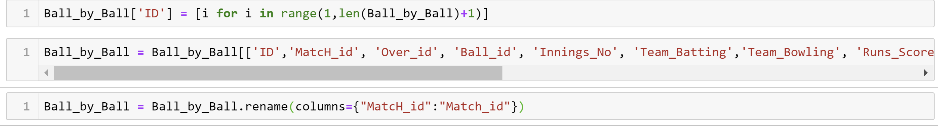

## 2. Table creation in MySql server

All the necessary tables are created in SQL as per ERD

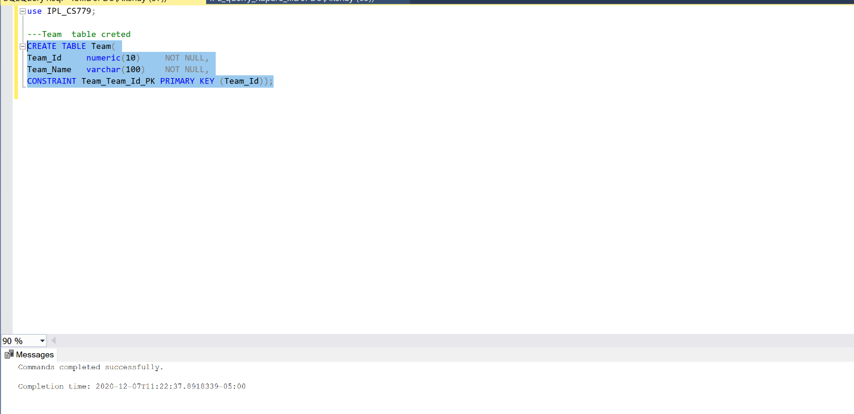

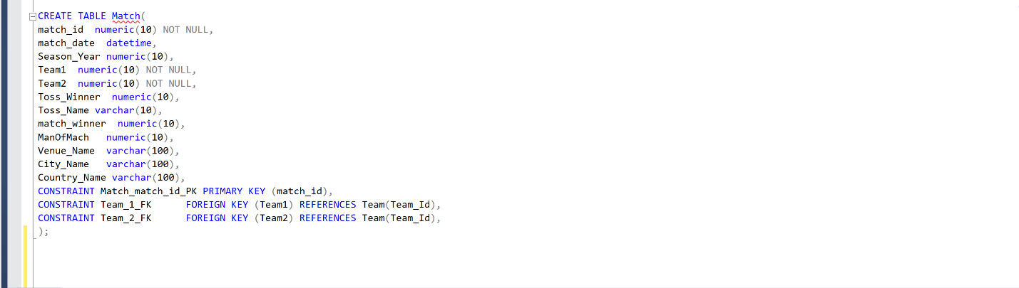

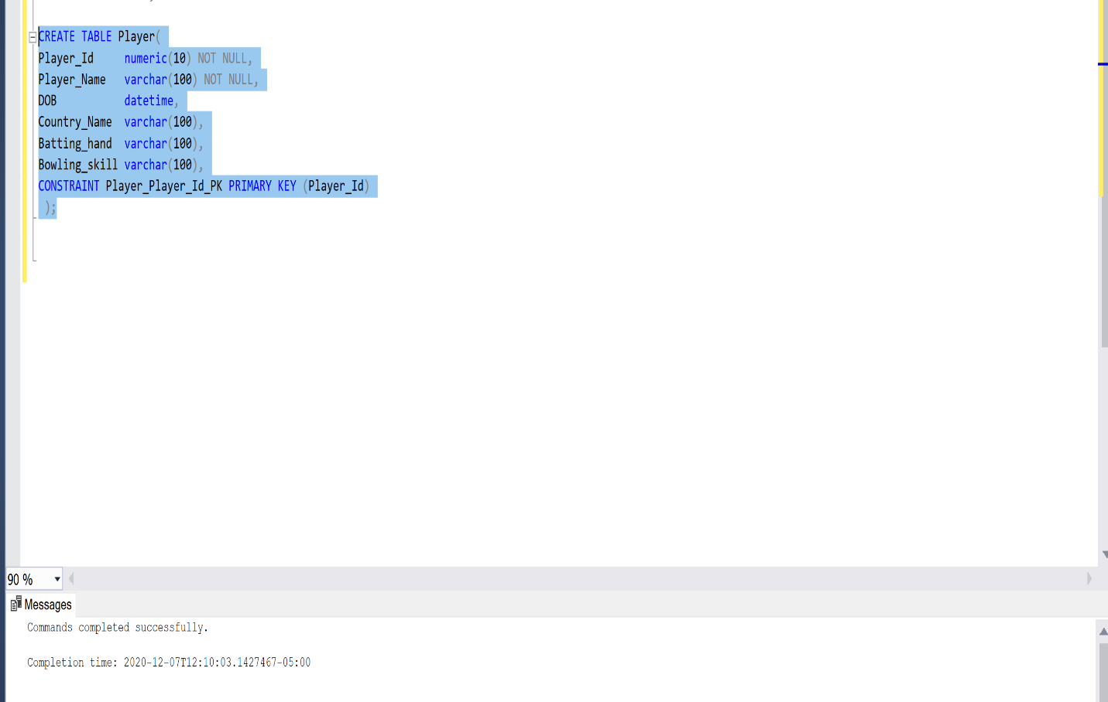

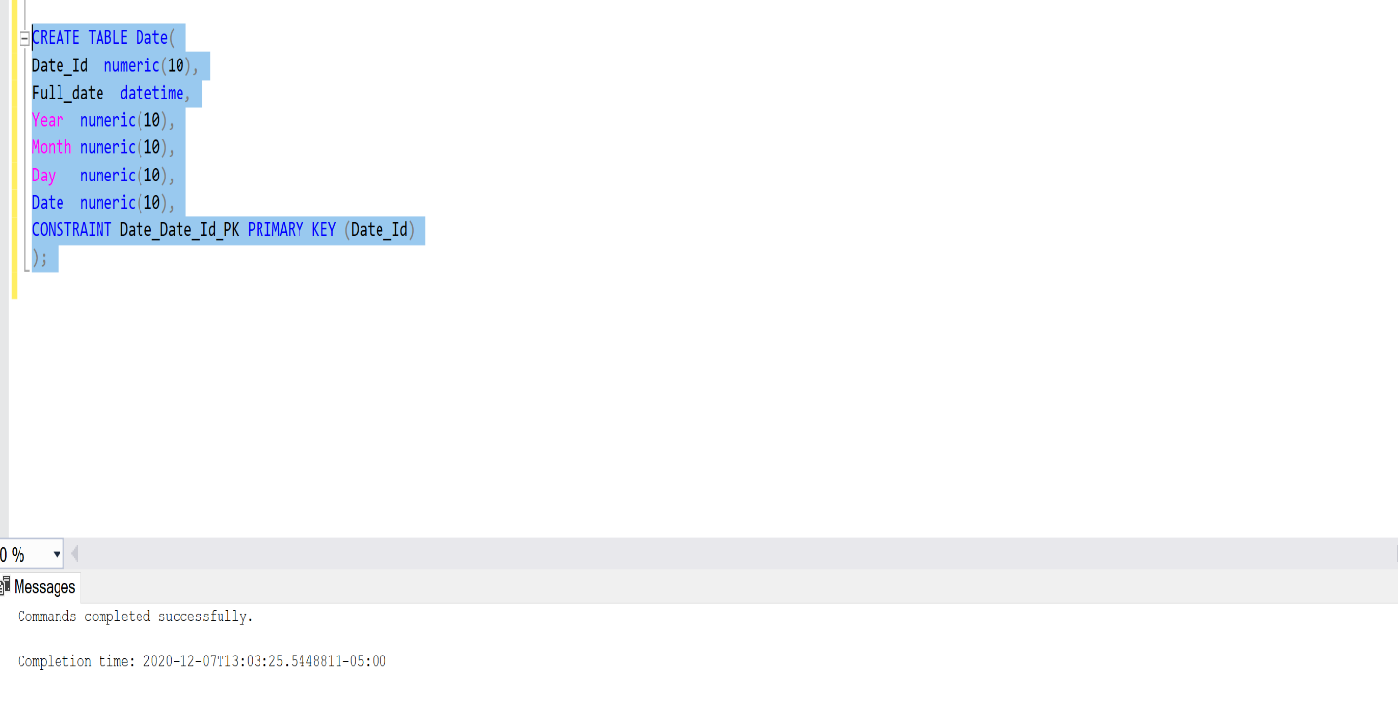

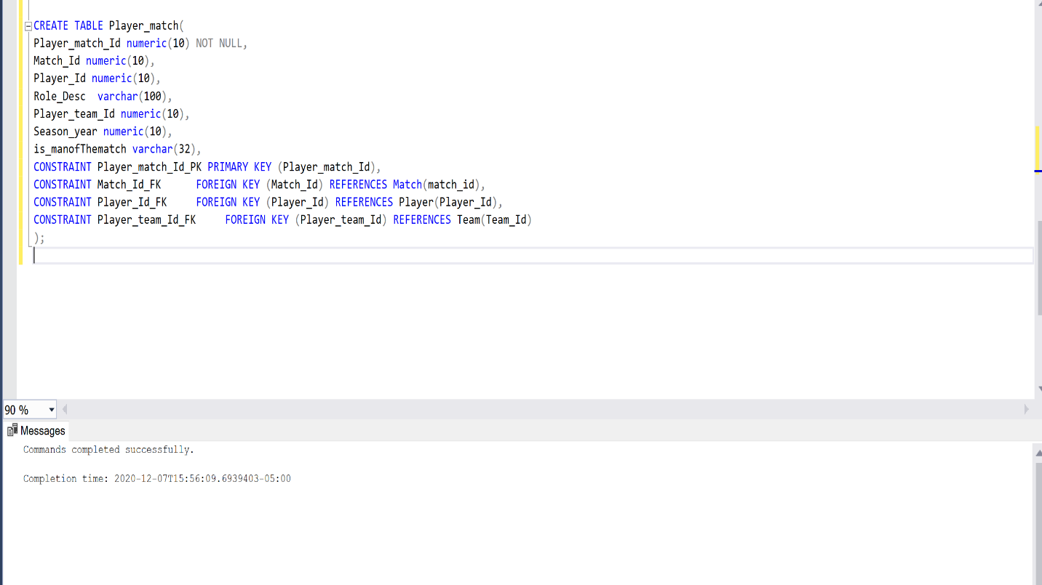

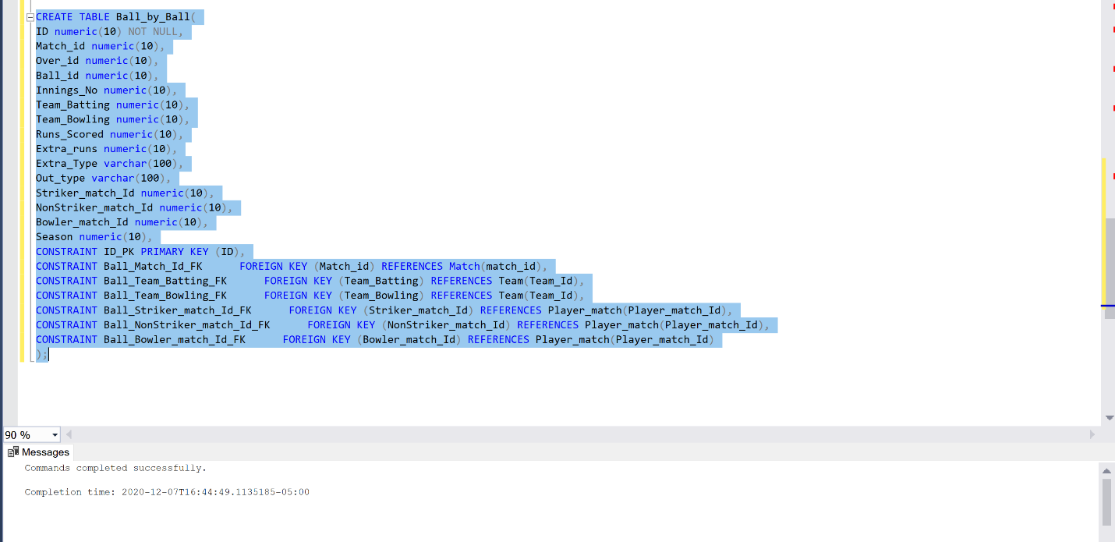

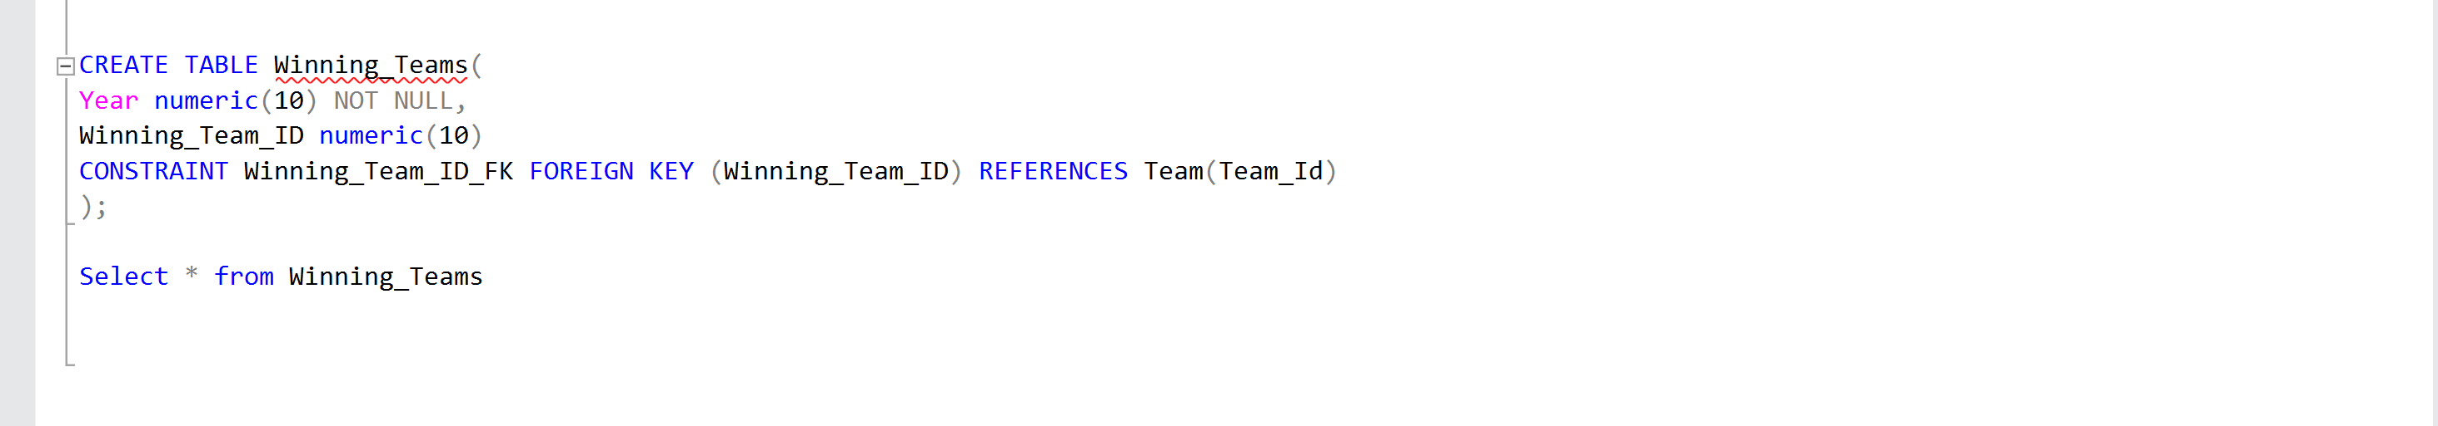

## 3. Connecting SQL to Python and adding Data to SQL database

1. I have used pydboc library to add all the data in Sql server.Here I am connecting my IPL database to from sql server to jupyter notebook

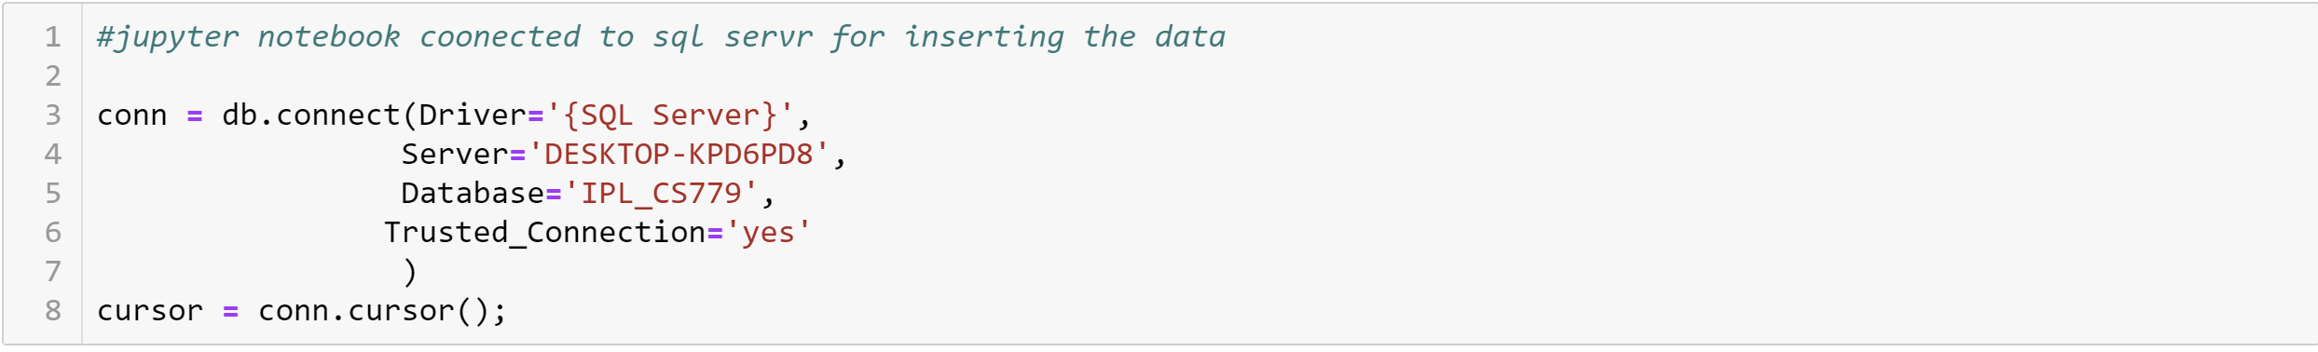

1. Adding row wise data to Team table from data frame

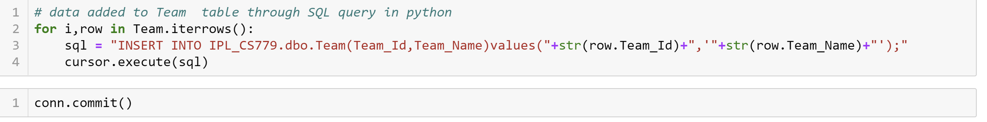

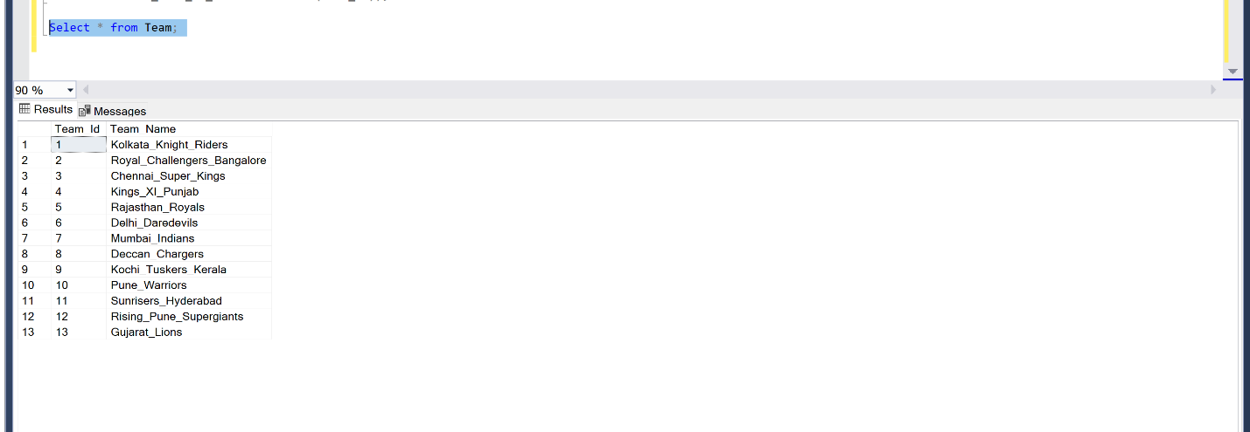

1. Adding row wise data to Player table from data frame

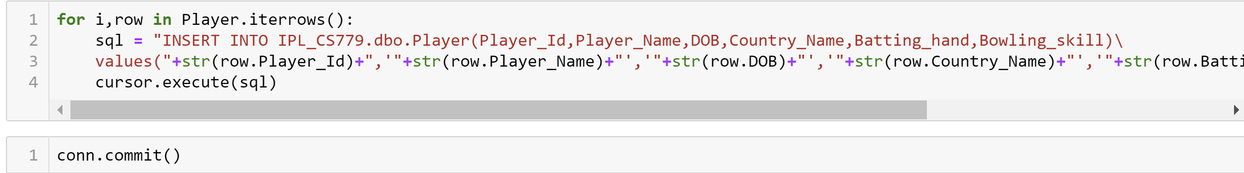

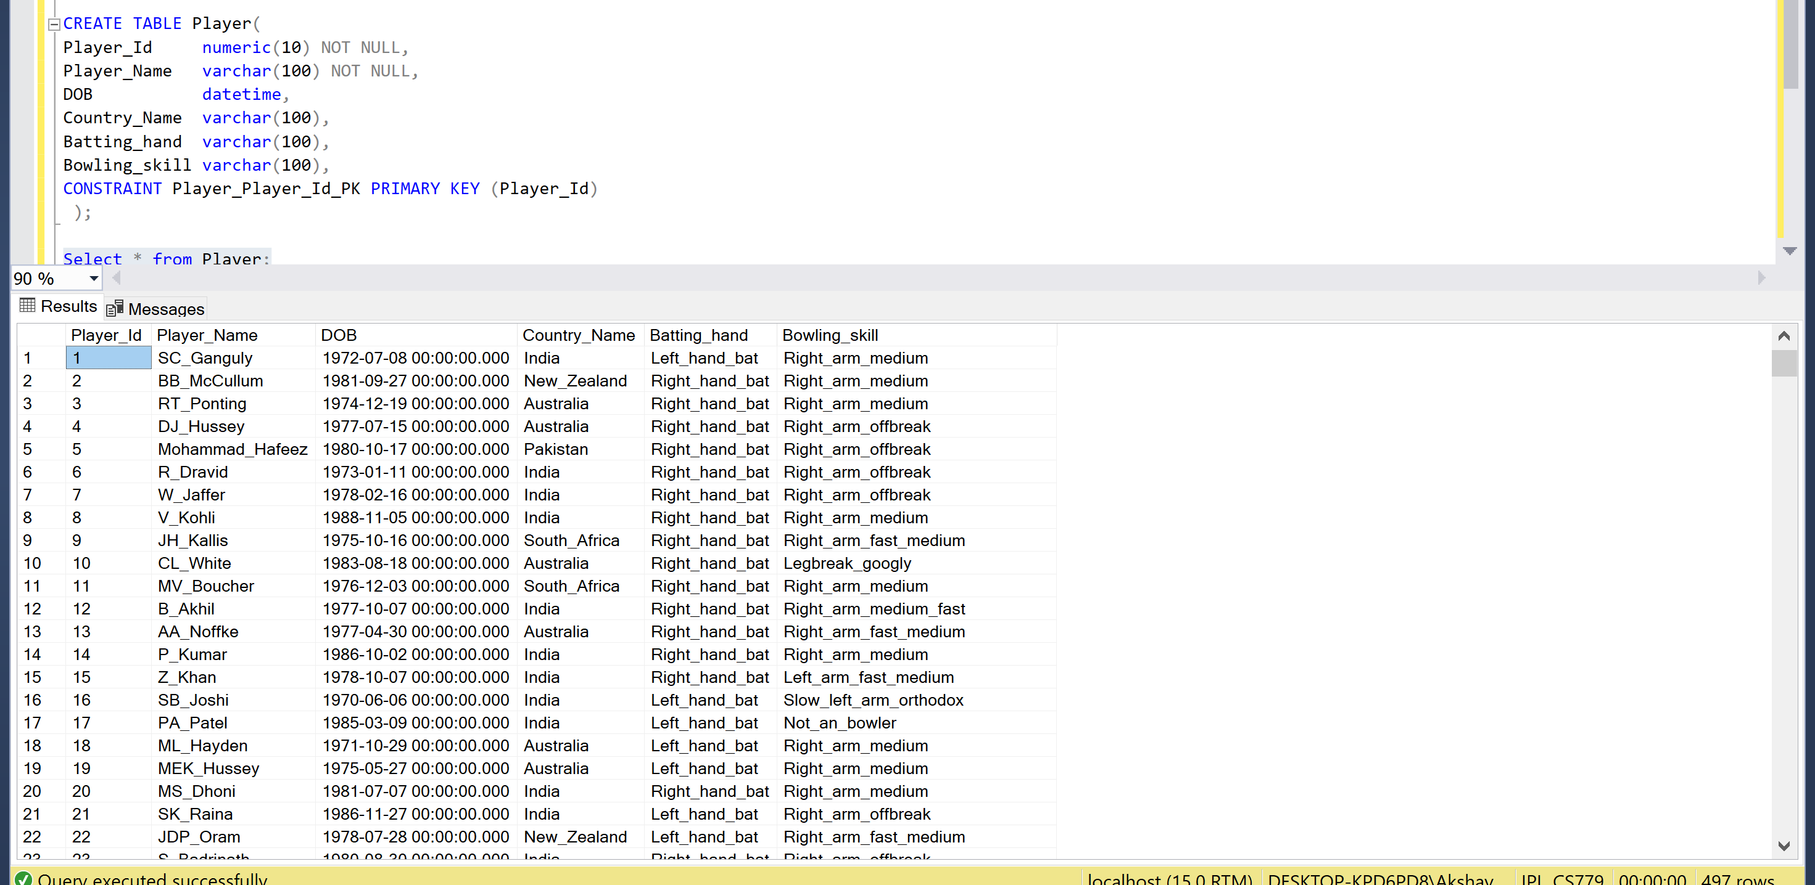

1. Adding row wise data to Match table from data frame

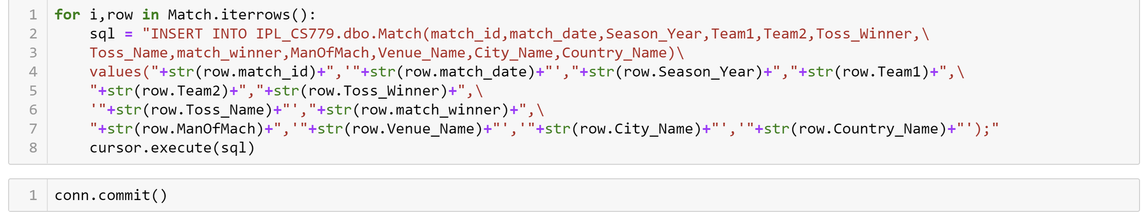

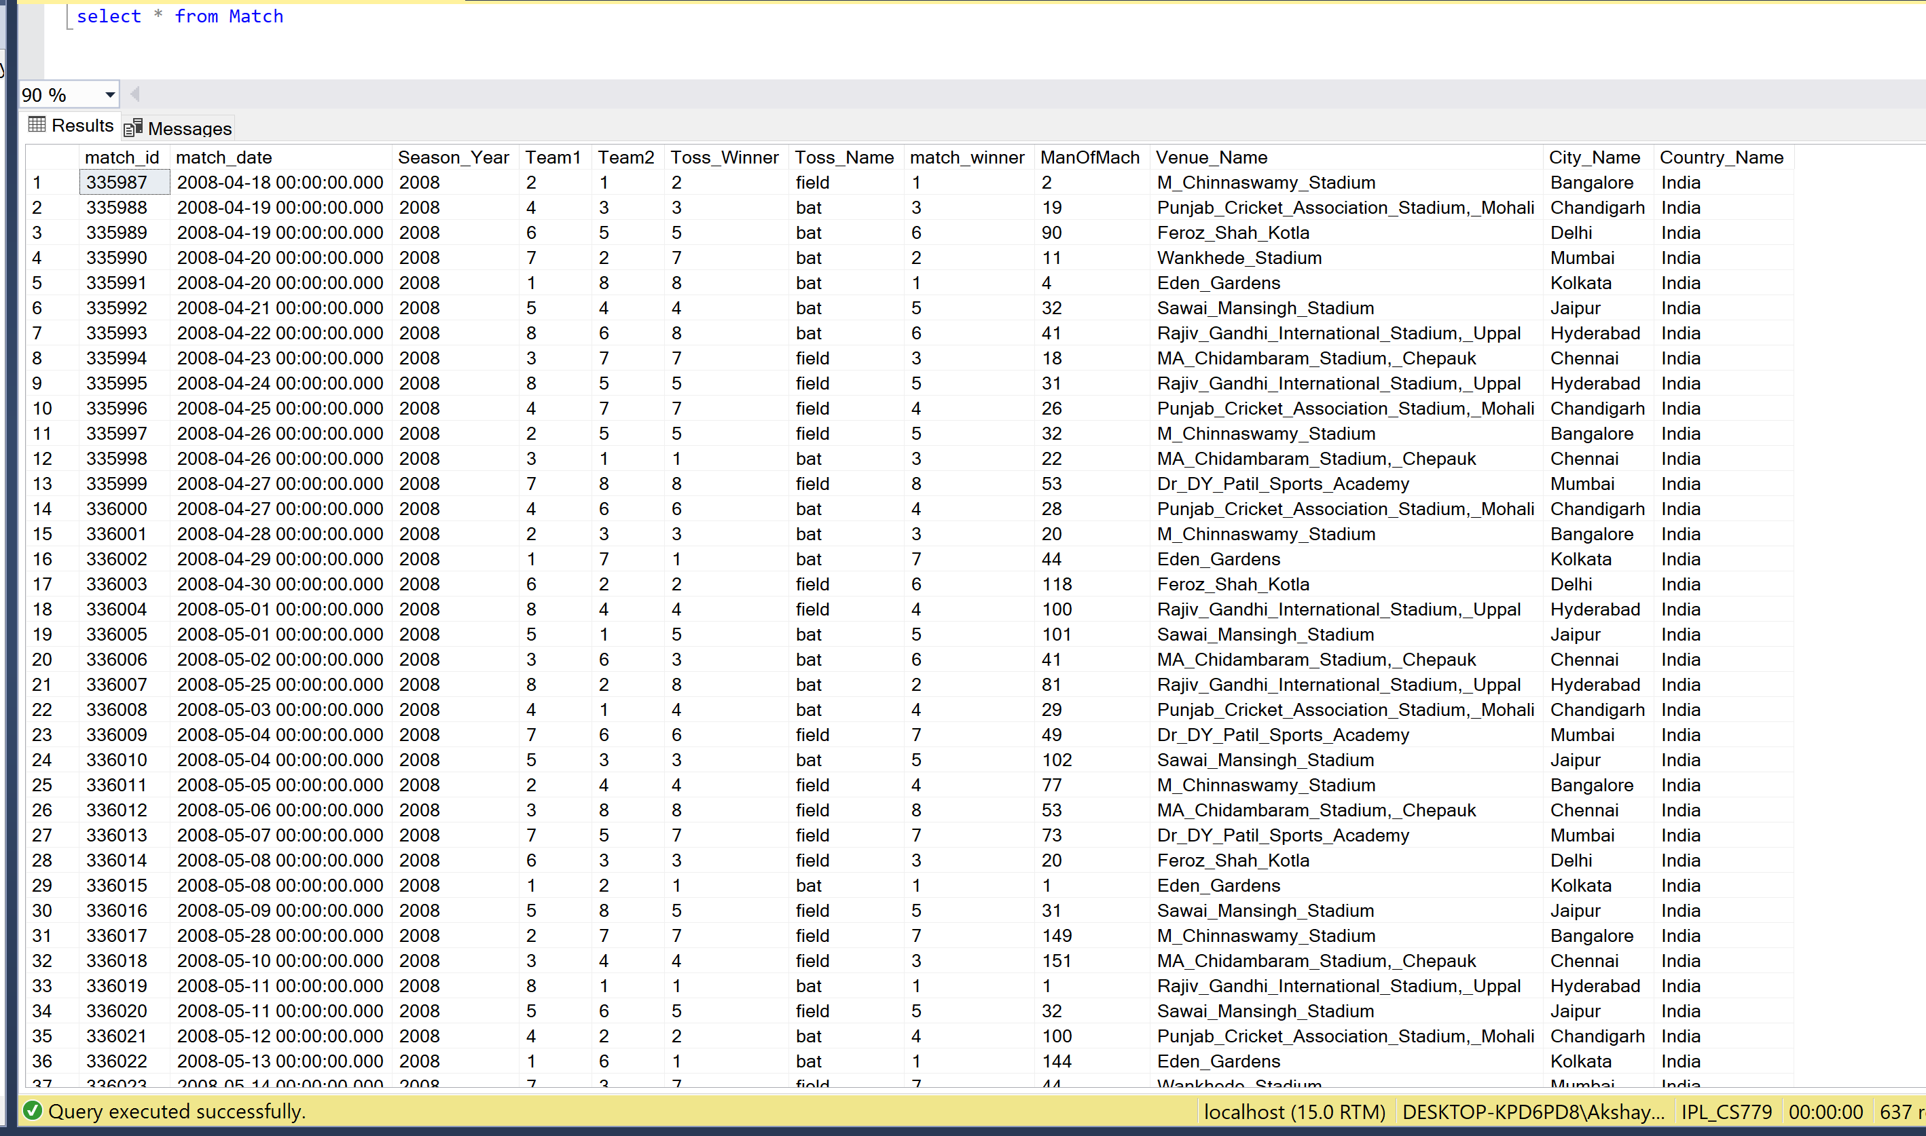

1. Adding row wise data to Player_Match table from data frame

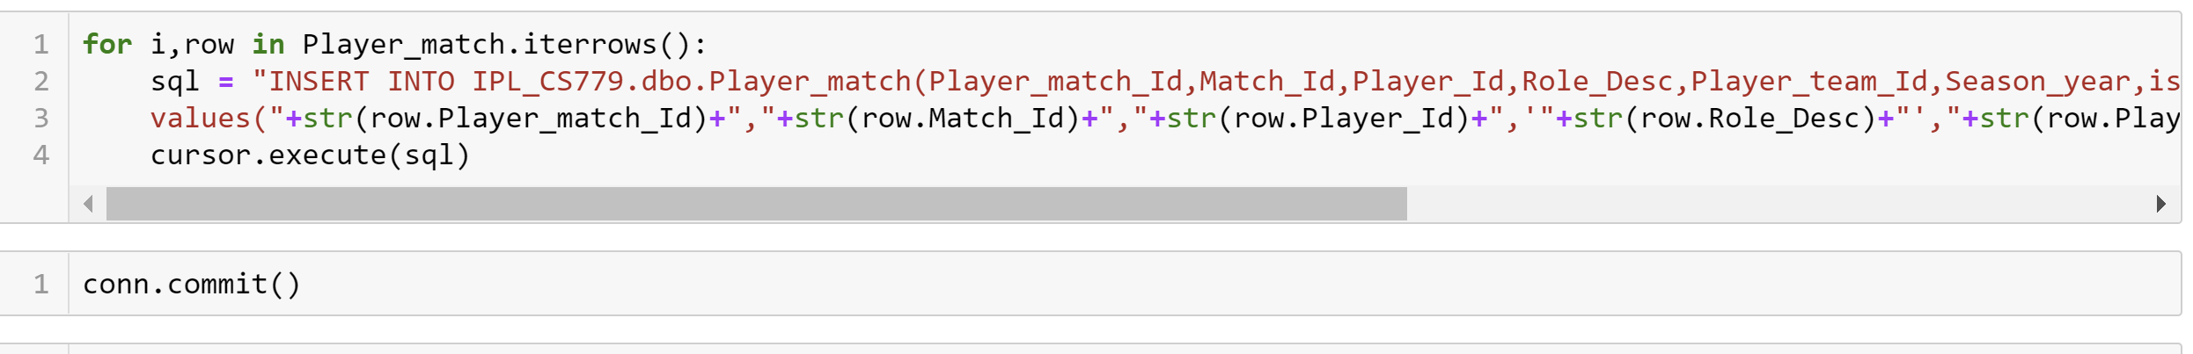

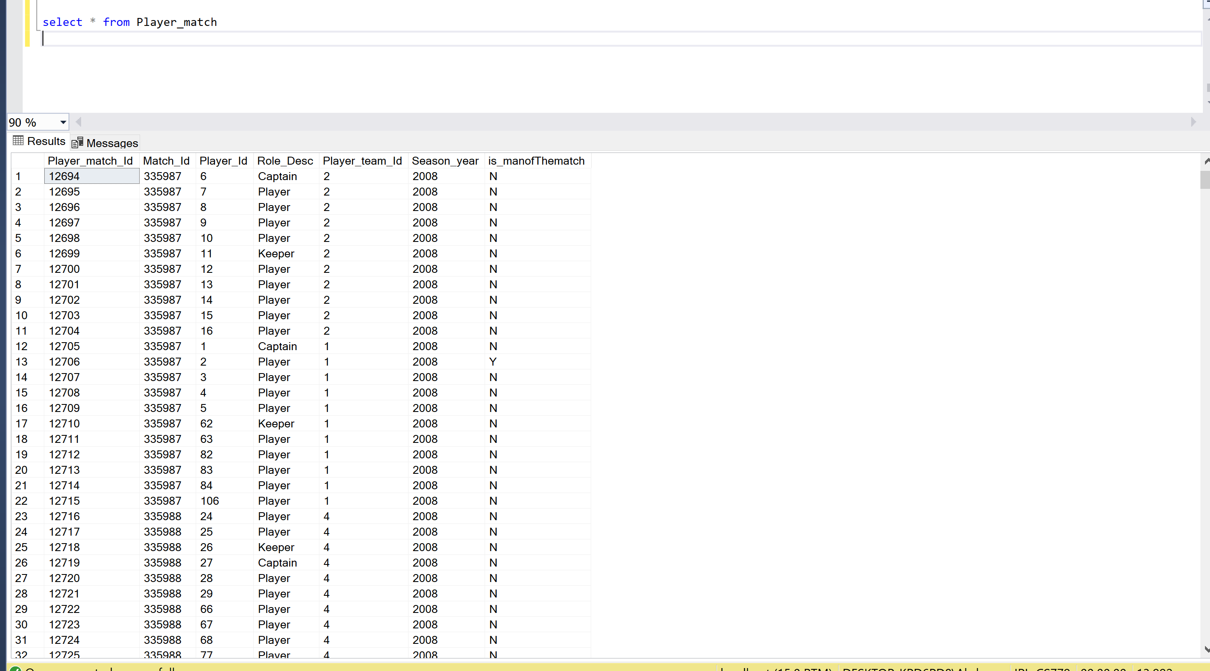

1. Adding row wise data to Ball by Ball table from data frame

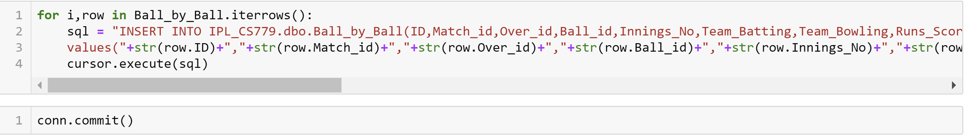

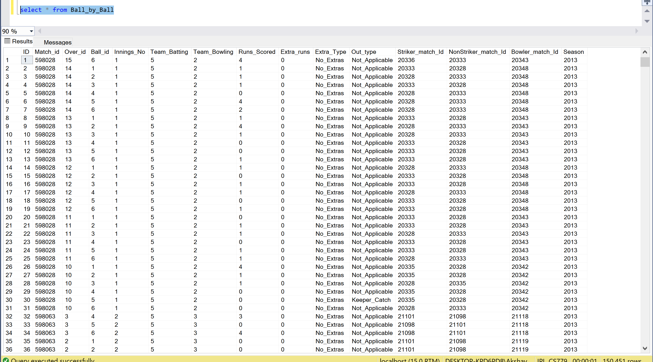

1. Adding row wise data to Winning_Teams table from data frame

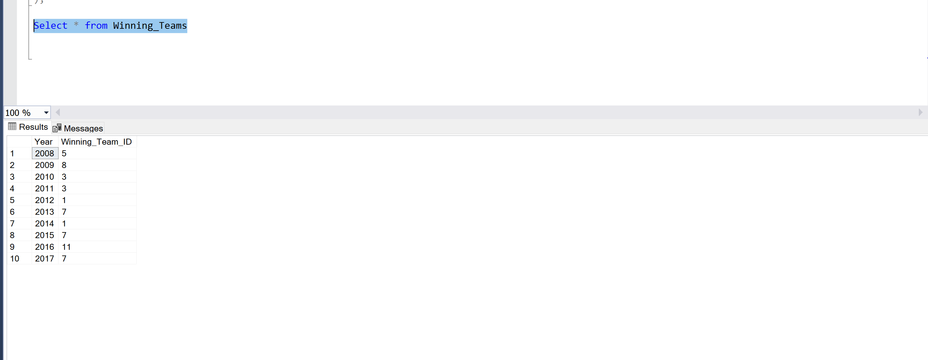

.

## 4. User define functions

I have created two functions after adding the data to database which will return Year wise information after passing year value to function and match information after passing match ID.

1. Season function:

After passing the year this function will return following information of that season

1. Year
2. Winner: Winner for that season
3. Total runs: Total runs scored in that year by all the teams
4. No. of Six: Total sixes in that year by all the teams
5. No. of Four: Total fours in that year by all the teams
6. No. of Wide balls: Total wide ball bowled in that year by all the teams
7. No. of NO balls: Total NO ball bowled in that year by all the teams
8. No. of Wickets: Total number of wickets taken in that year by all the teams

Code:

CREATE FUNCTION Season(@Year int)

returns @Season_Info table(

Year int,

Winner varchar(100),

Total_runs int,

No_of_Six int,

No_of_Four int,

No_of_Wide_Balls int,

No_of_NO_Balls int,

No_of_Wickets int)

as

begin

declare @Season int;

declare @Winner varchar(100);

declare @run_scored int;

declare @extra_run int;

declare @Total_runs int;

declare @No_of_Six int;

declare @No_of_Four int;

declare @No_of_Wide_Balls int;

declare @No_of_NO_Balls int;

declare @No_of_Wickets int;

Set @Season = @Year

set @Winner = (Select Team_Name from Team

join Winning_Teams on Team.Team_Id = Winning_Teams.Winning_Team_Id

where Winning_Teams.Year = @Year )

set @run_scored = (select sum(Runs_Scored) from Ball_by_Ball where season = @Year group by season)

set @extra_run = (select sum(Extra_runs) from Ball_by_Ball where season = @Year group by season)

set @Total_runs = @run_scored + @extra_run

set @No_of_Six = (select count(Runs_Scored) from Ball_by_ball where (season = @Year AND Runs_Scored = 6) group by season)

set @No_of_Four = (select count(Runs_Scored) from Ball_by_ball where (season = @Year AND Runs_Scored = 4)group by season)

set @No_of_Wide_Balls = (select count(Extra_Type) from Ball_by_ball where (season = @Year AND Extra_Type = 'wides' ) group by season)

set @No_of_NO_Balls = (select count(Extra_Type) from Ball_by_ball where (season = @Year AND Extra_Type = 'Noballs' ) group by season)

set @No_of_Wickets = (select count(Out_type) from Ball_by_ball where (season = @Year AND Out_type != 'Not_Applicable' AND Out_type != 'obstructing_the_field' AND Out_type != 'retired_hurt') group by season)

insert into @Season_Info values(@Season,@Winner,@Total_runs,@No_of_Six,@No_of_Four,@No_of_Wide_Balls,@No_of_NO_Balls,@No_of_Wickets)

return

end;

In this function I am returning table which will contain all the information we want to fetch per year.

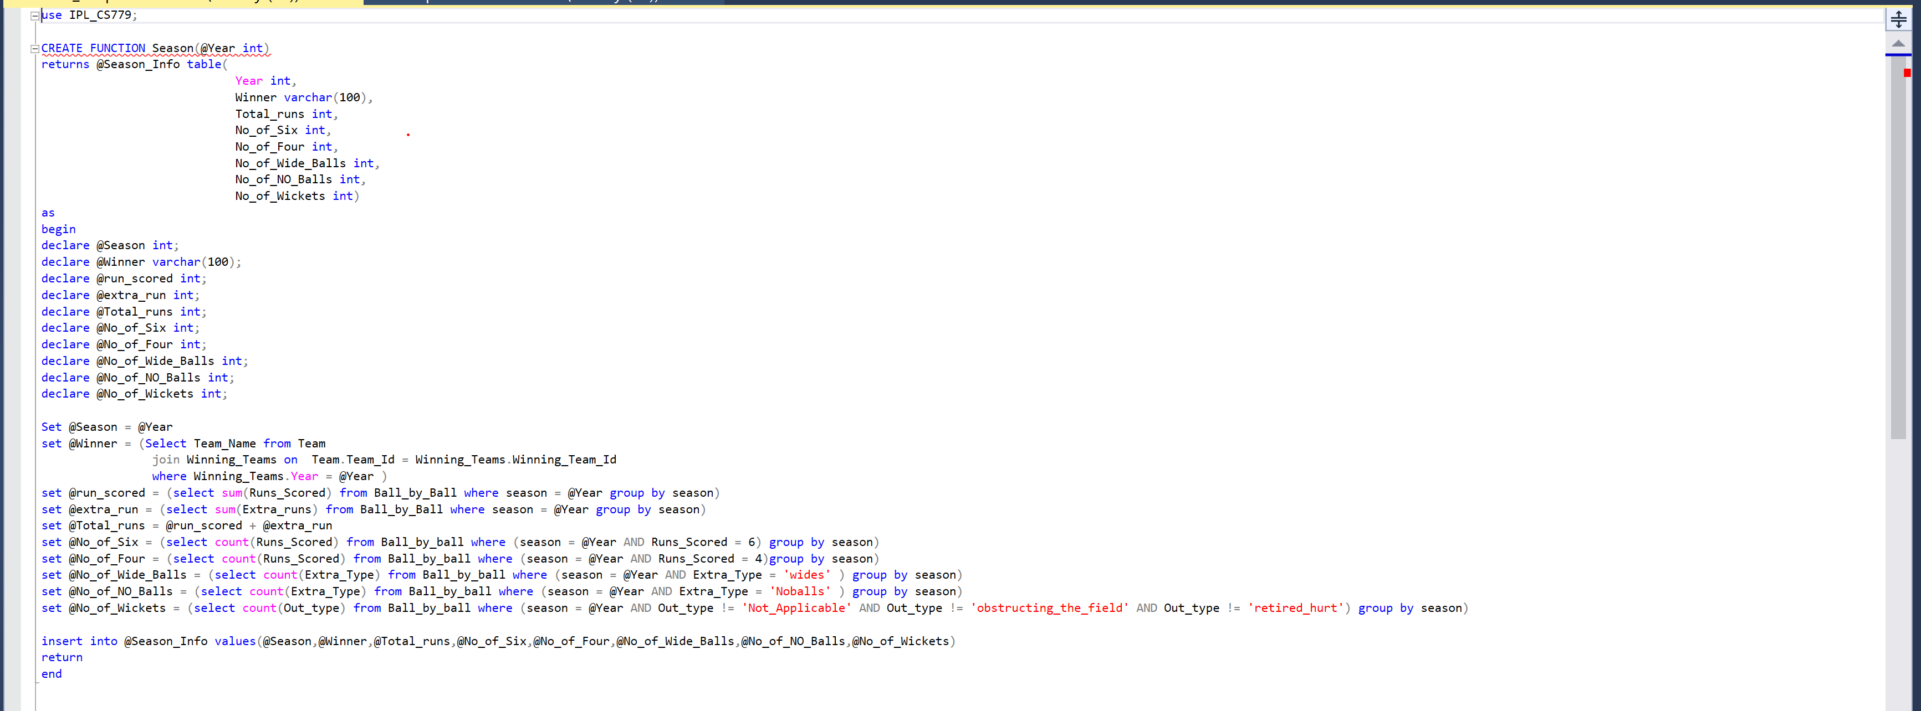

Outputs:

For following output we can see all the information for year 2009 and 2014

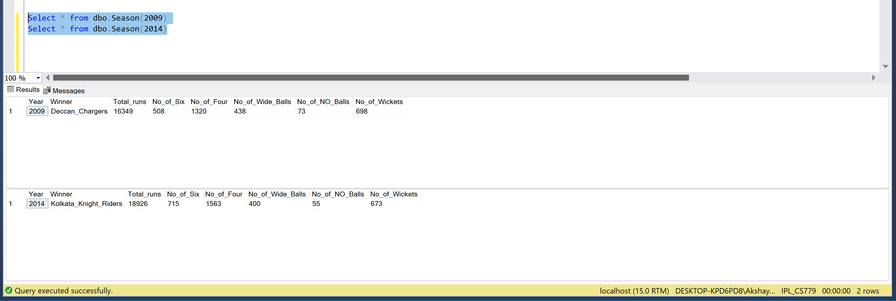

Error Case:

In case year passed by the user is not valid or no data is present in that case my function will return Null values for all the data

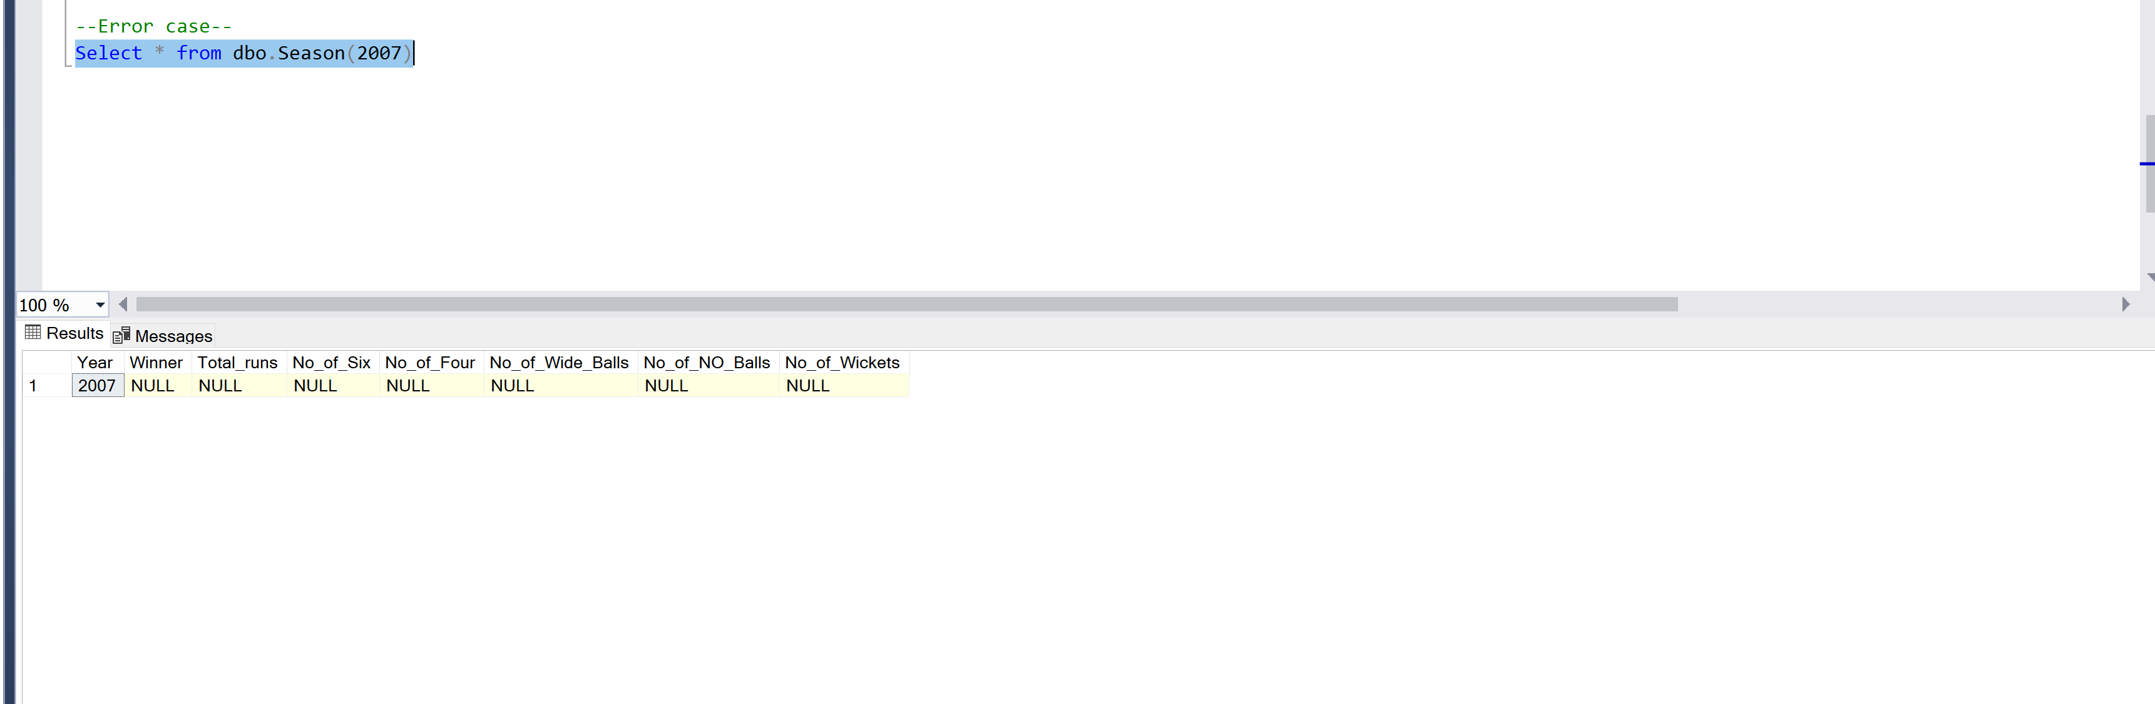

1. Match Info function:

In this function after passing Match ID will get following information about that match

a. Match_Date: On which date match is played

b. Team1

c. Team2

d. Toss_winner: Which team won the Toss

e. Match_winner: Which team on the match

f. Man_of_the_Match: Best player of that match

g. Stadium: Venue of the match

Code:

CREATE FUNCTION Match_info(@Match_Id int)

returns @Match_info table(

Match_Date Datetime,

Team1 varchar(100),

Team2 varchar(100),

Toss_winner varchar(100),

Match_winner varchar(100),

Man_of_the_Match varchar(100),

Stadium varchar(100))

as

begin

declare @Match_date datetime;

declare @Team1_Name varchar(100);

declare @Team2_Name varchar(100);

declare @Toss_winner_id integer;

declare @Match_winner_id integer;

declare @Man_of_the_Match_id integer;

declare @Stadium varchar(100);

declare @Toss_winner_Name varchar(100);

declare @Match_winner_Name varchar(100);

declare @Man_of_the_Match_name varchar(100);

declare @invalid_match_id integer;

set @Match_date = (select match_date from match where match_id = @Match_Id)

set @Team1_Name = (select Team_Name from Team

join Match on Team.Team_Id = Match.Team1

where Match.match_id = @Match_Id)

set @Team2_Name = (select Team_Name from Team

join Match on Team.Team_Id = Match.Team2

where Match.match_id = @Match_Id)

Set @Stadium = (select Venue_Name from Match where match_id = @Match_Id)

Set @Toss_winner_id = (select Toss_Winner from Match where match_id = @Match_Id)

if @Toss_winner_id = 0

BEGIN

Set @Toss_winner_Name = 'Match_abandoned'

end

else

begin

set @Toss_winner_Name = (select Team_Name from team where Team_Id = @Toss_winner_id)

end

Set @Match_winner_id = (select match_winner from Match where match_id = @Match_Id)

if (@Match_winner_id = 0)

begin

set @Match_winner_Name = 'No result'

set @Man_of_the_Match_name = 'No result'

end

else

begin

set @Match_winner_Name = (select Team_Name from team where Team_Id = @Match_winner_id)

set @Man_of_the_Match_id = (select manofmach from match where match_id = @Match_Id)

set @Man_of_the_Match_name = (select player_name from player where Player_Id = @Man_of_the_Match_id)

end

insert into @Match_info values(@Match_date,@Team1_Name,@Team2_Name,@Toss_winner_Name,@Match_winner_Name,@Man_of_the_Match_name,@Stadium)

return

end

Output:

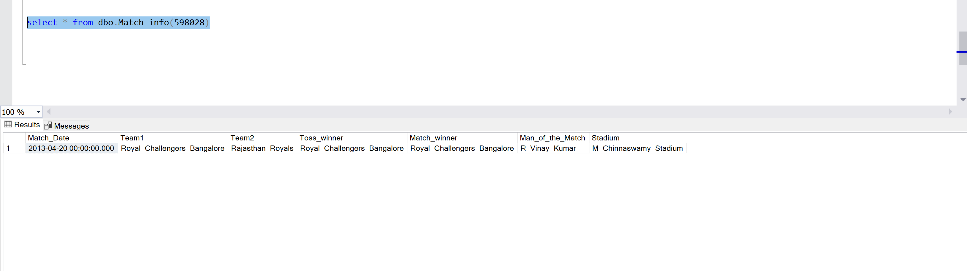

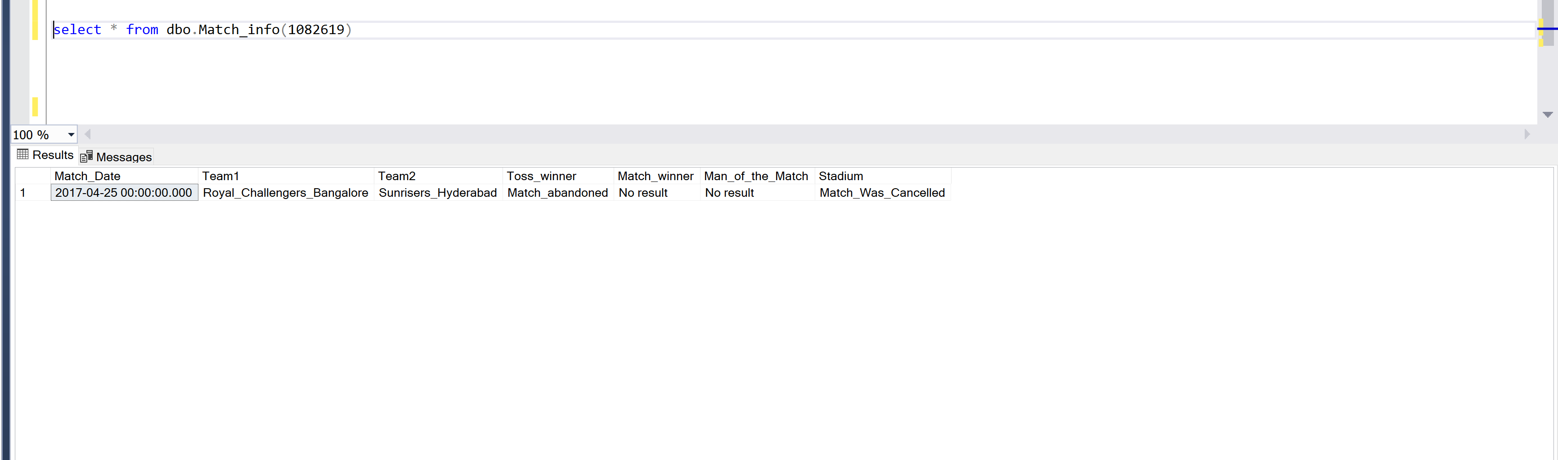

In case we send invalid match ID:

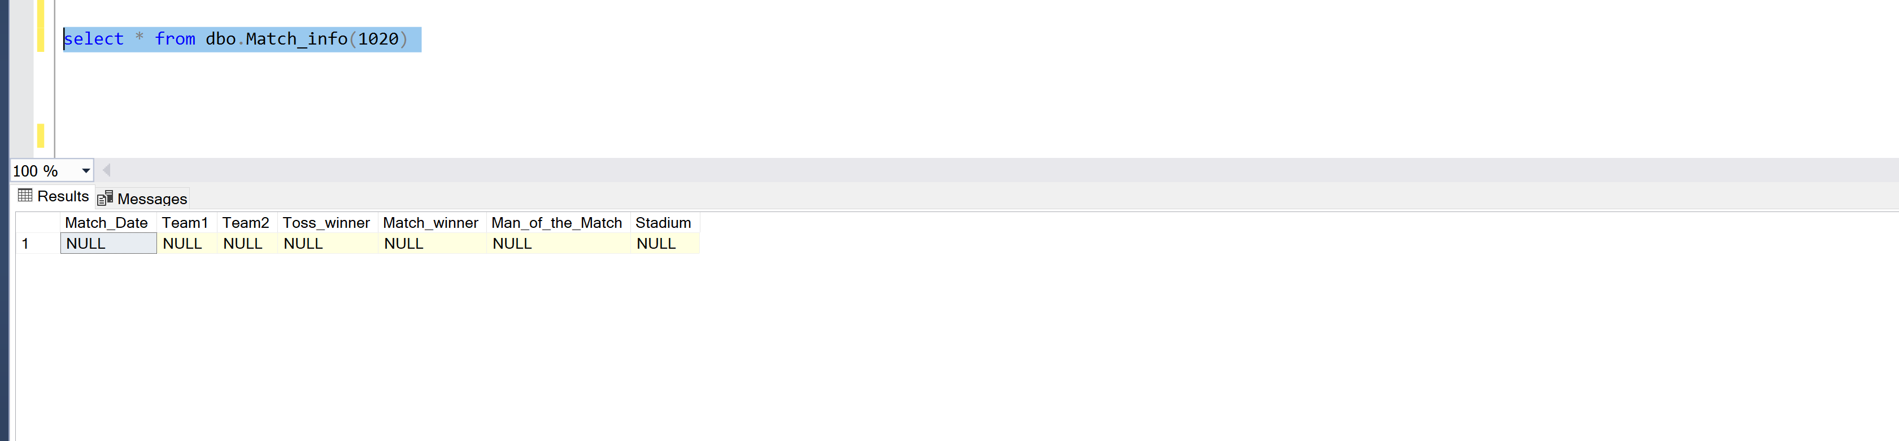

## 5. Analysis on IPL dataset

I have used Powe BI to show some graphical analysis on the data. I have connect my Data set to Power BI and performed and analysis on the data

1. Count of player won the man of the match for all the season

Each color displays role of the player also.

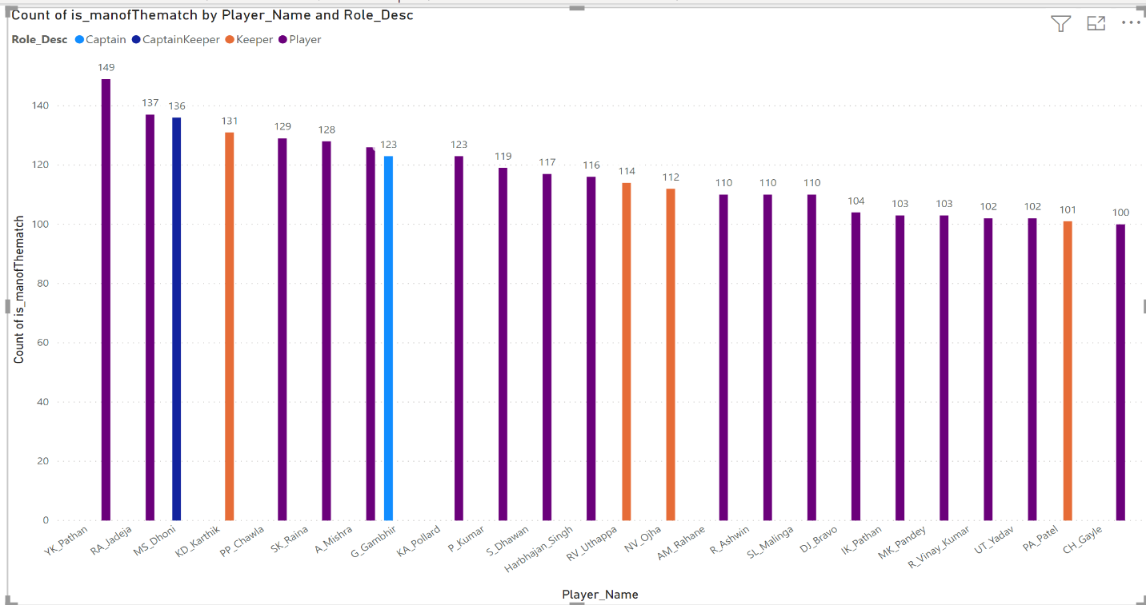

1. Pie chart of percentage of matches played in each stadium

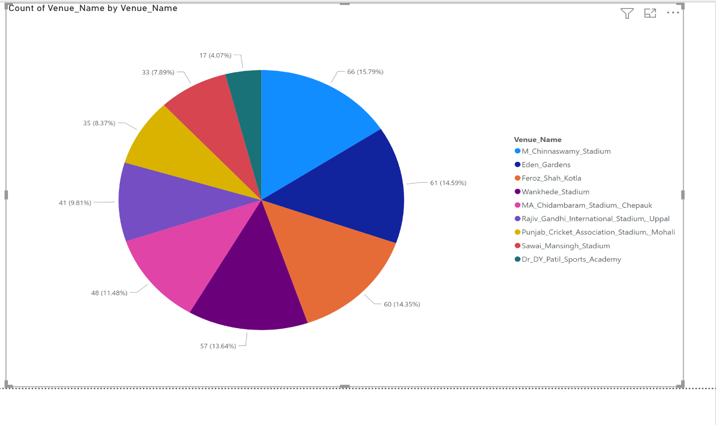

1. Map of which part of India matches are conducted

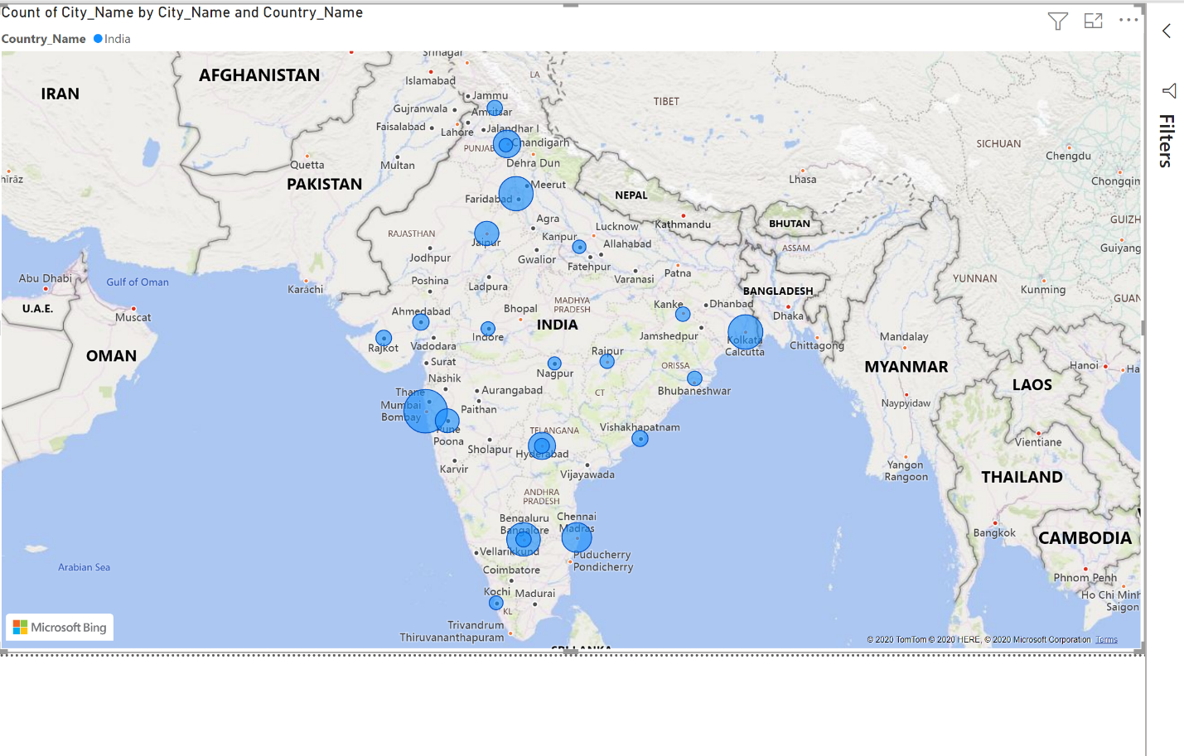

1. Pie chart of by which type most runs scored

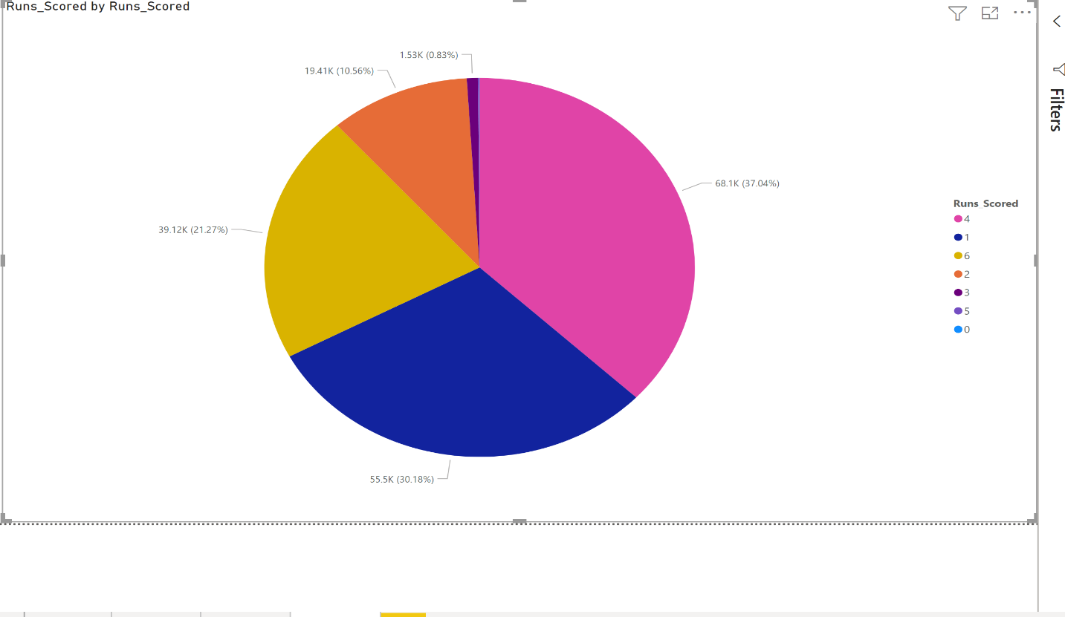

1. Pie chart of total number of extra balls bowled in all the seasons

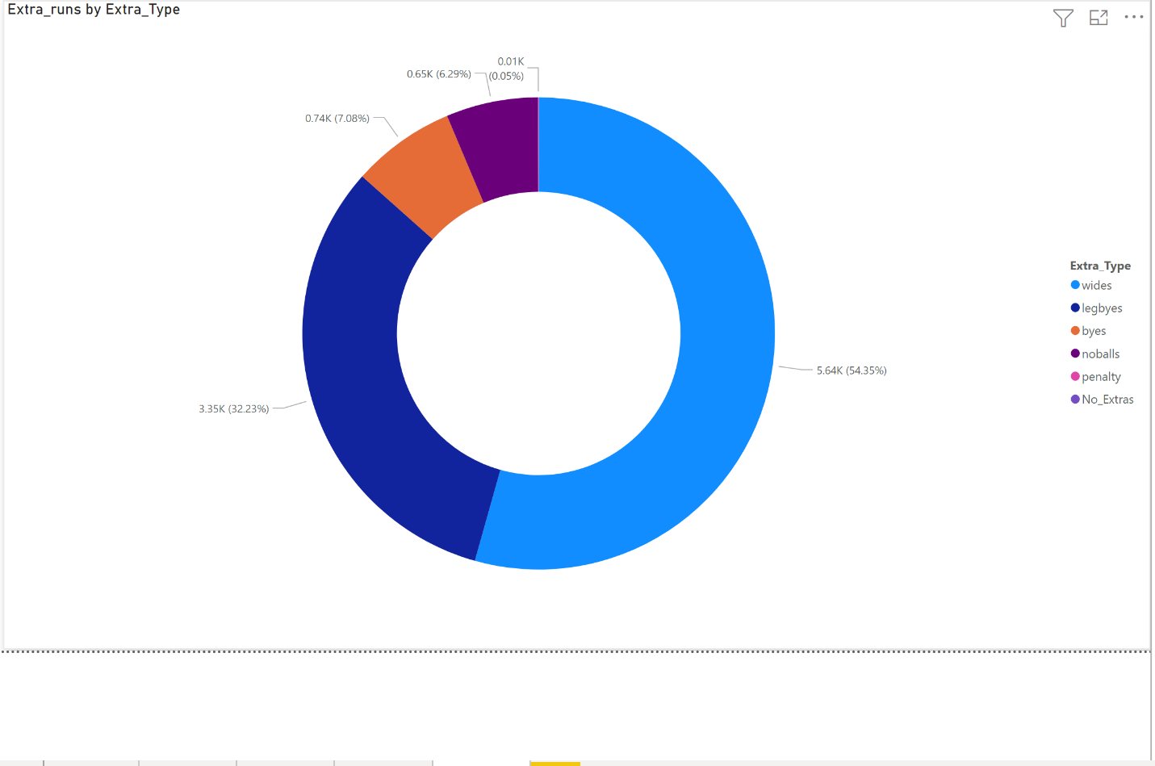

1. Run scored by the each captain

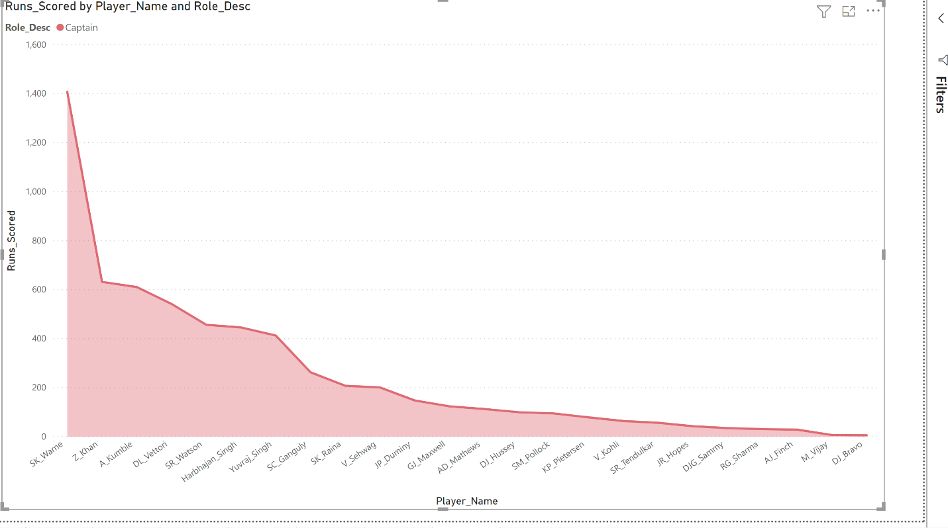

# Design Implementation for IPL dataset with Weather data

## 1. Preprocessing for CSV files

1.Loading Weather data :

Converting CSV to data frame and taking all the dates available in Dataset

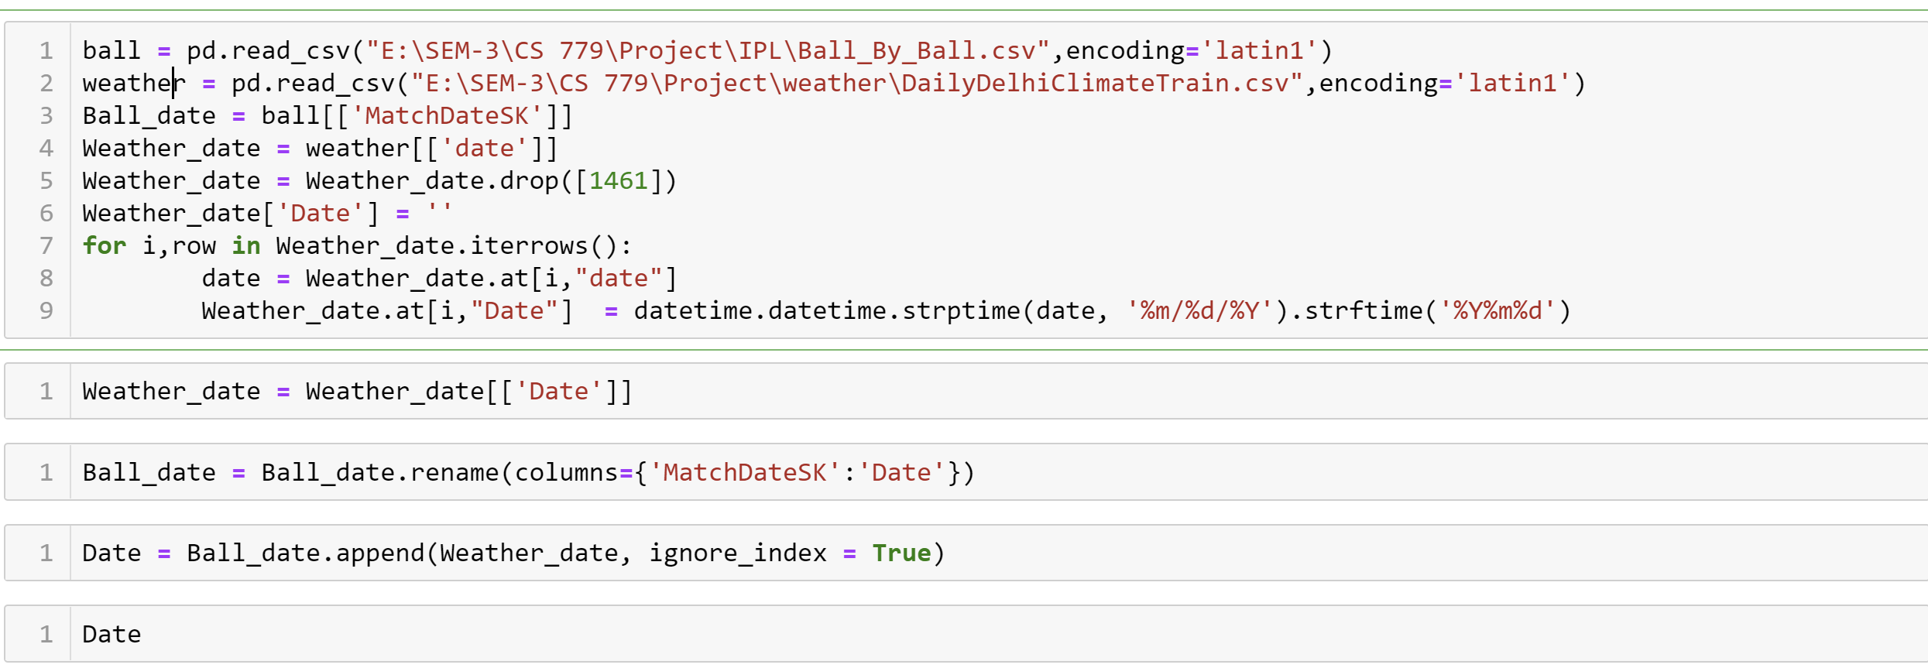

After fetching all the Dates from weather and match data I have drop all the duplicates value and make Date Data frame with all unique values and assigned ID to it

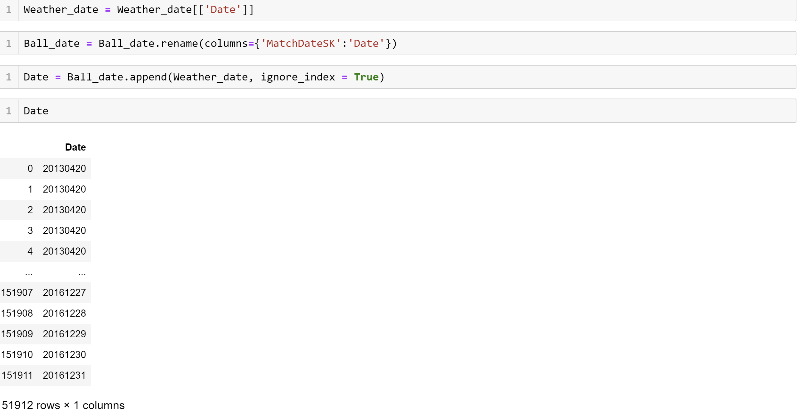

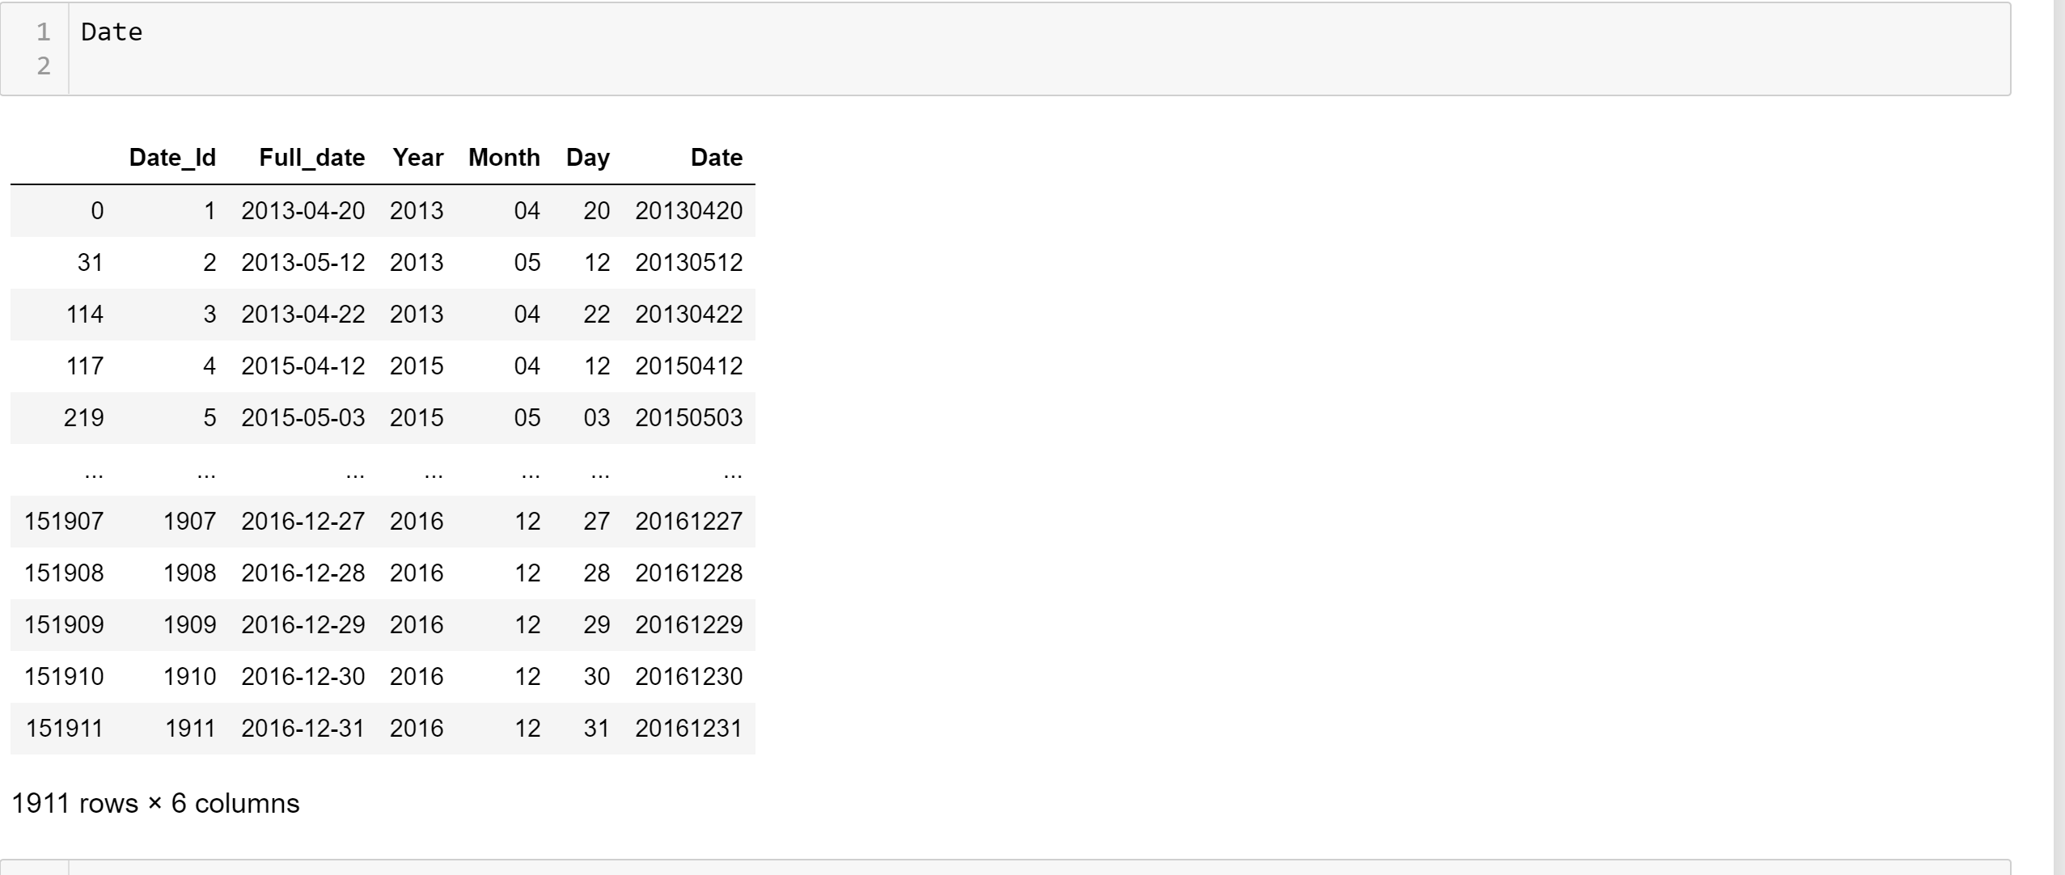

As my Weather data has only Delhi weather I have taken only matches which are player in Delhi

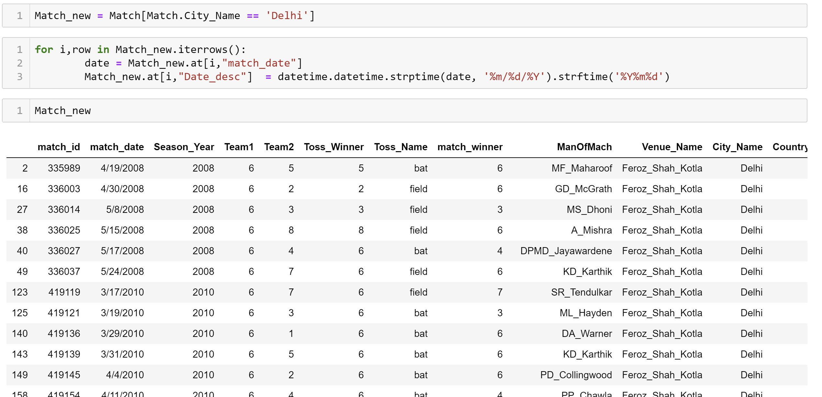

After that Using merge function I linked match IDs with respetive Weathers on the basis in Dates in weather dataset

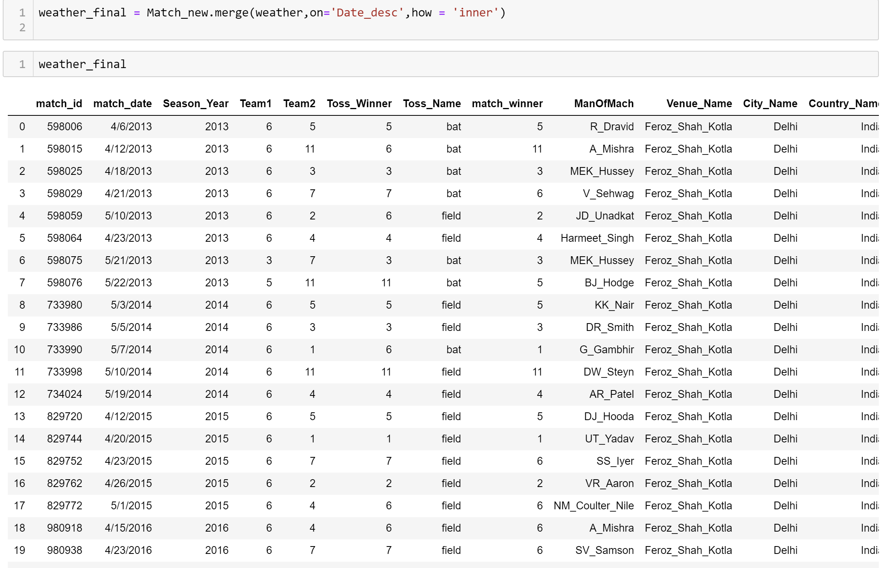

From Ball by Ball dataset I have calculated the Runs scored by each team in Each match and attached it with my weather data set

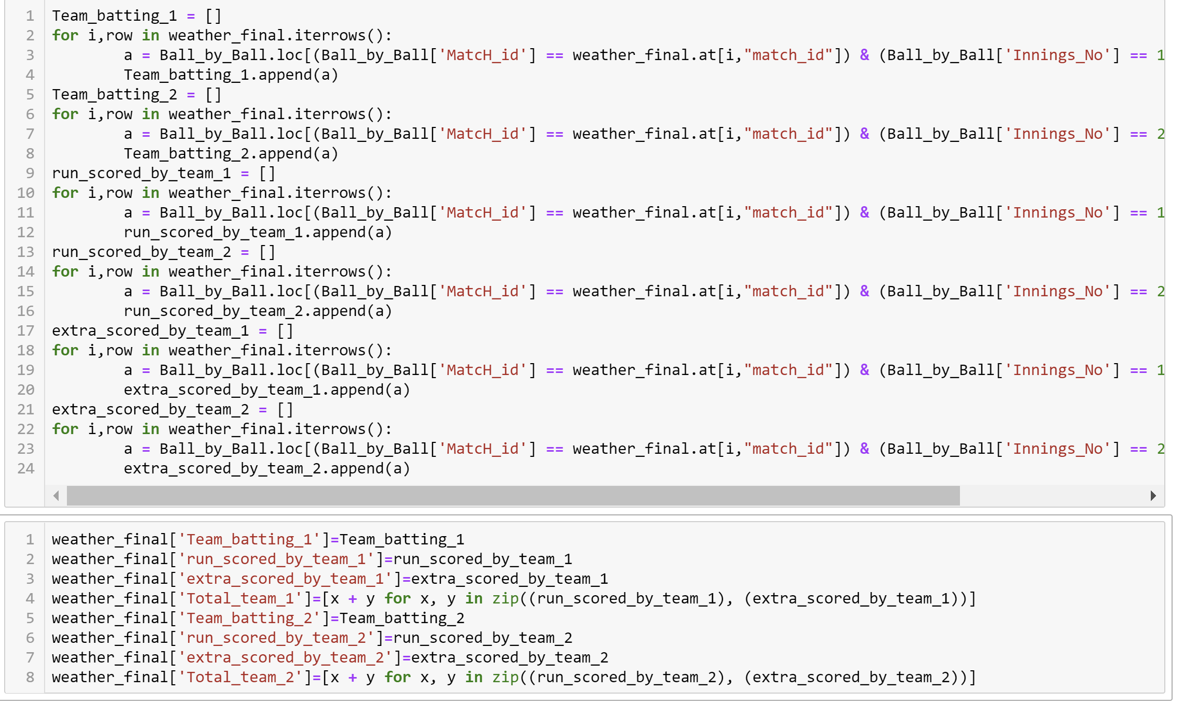

Finally my weather data set contains following values:

1. Match ID
2. Match Date
3. Team 1
4. Team 2
5. Toss winner
6. Match winner
7. Decision made by toss winner
8. Match winner ID
9. Man of the match
10. Venue
11. Date
12. Mean Pressure
13. Mean Teamp
14. Wind speed
15. Humidity
16. Team batting
17. Team bowling
18. Total run by each team
19. Extra Runs by each team

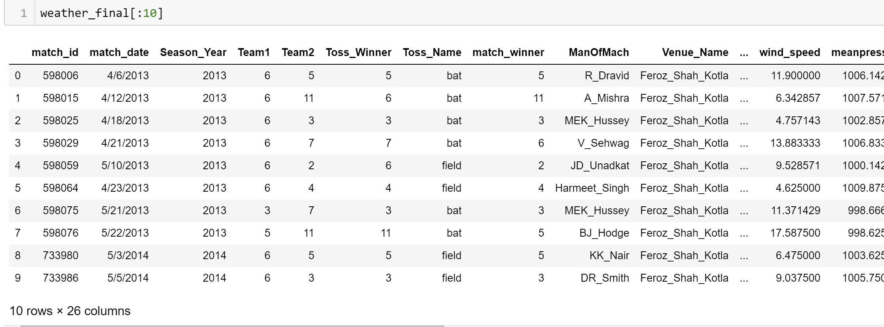

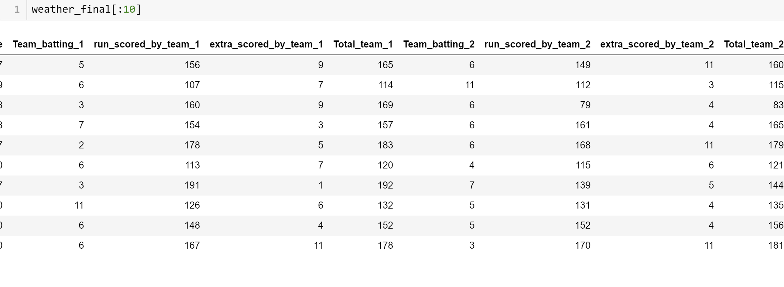

## 2. Analysis on Match w.r.t Weather

1.Average Run scored by Team bated 1st and Team Bated 2nd w.r.t mean pressure

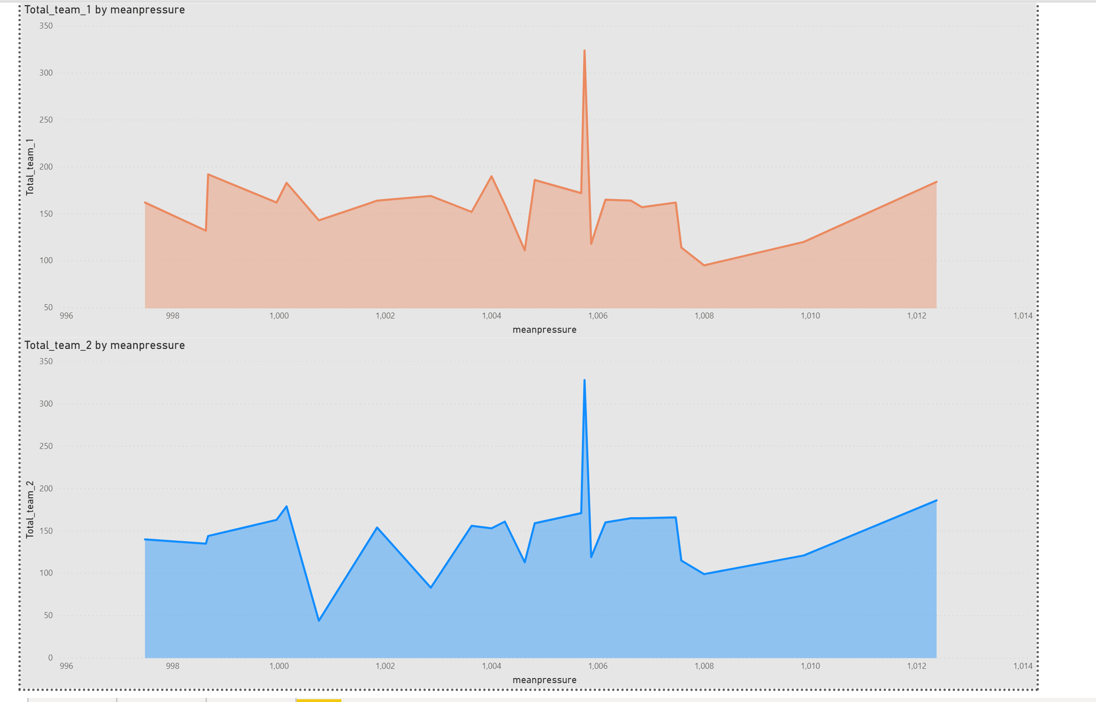

2.Average Run scored by Team bated 1st and Team Bated 2nd w.r.t mean temperature

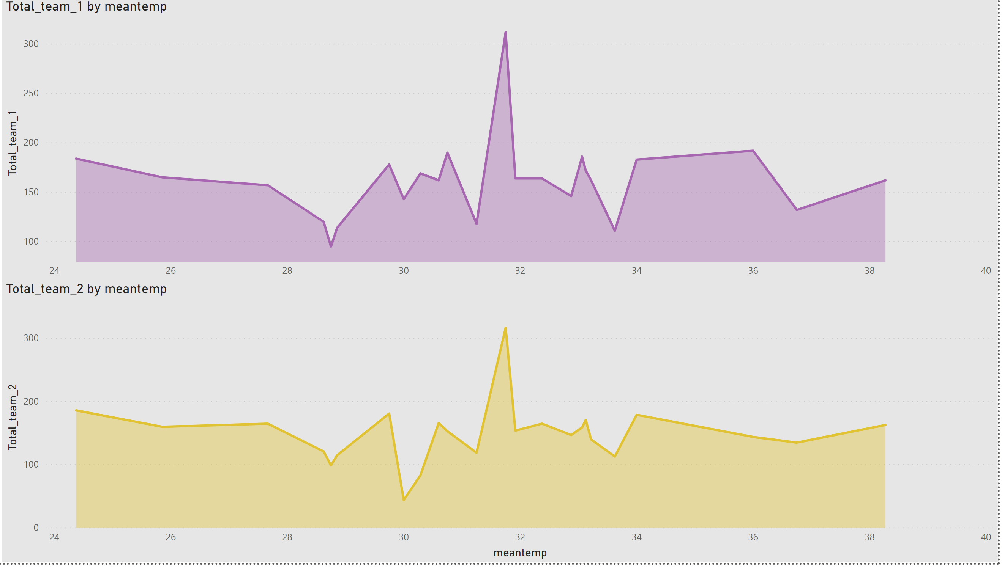

3.Average Run scored by Team bated 1st and Team Bated 2nd w.r.t humidity

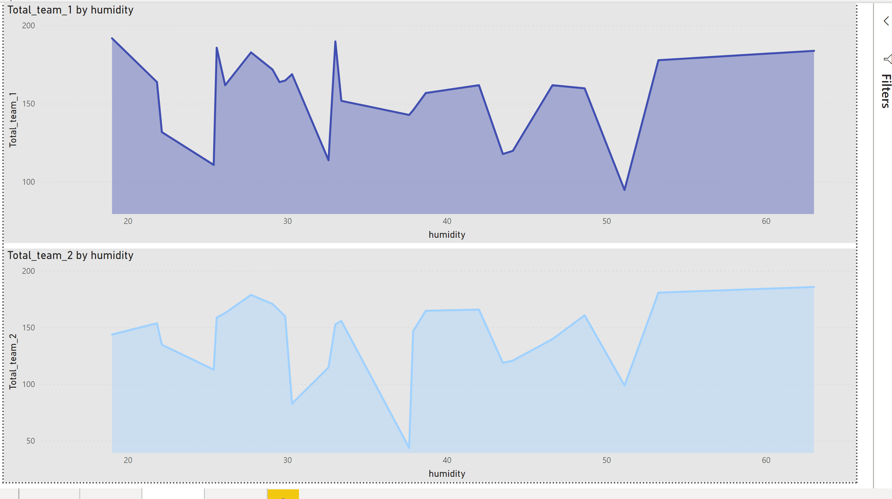

4.Average Run scored by Team bated 1st and Team Bated 2nd w.r.t wind speed

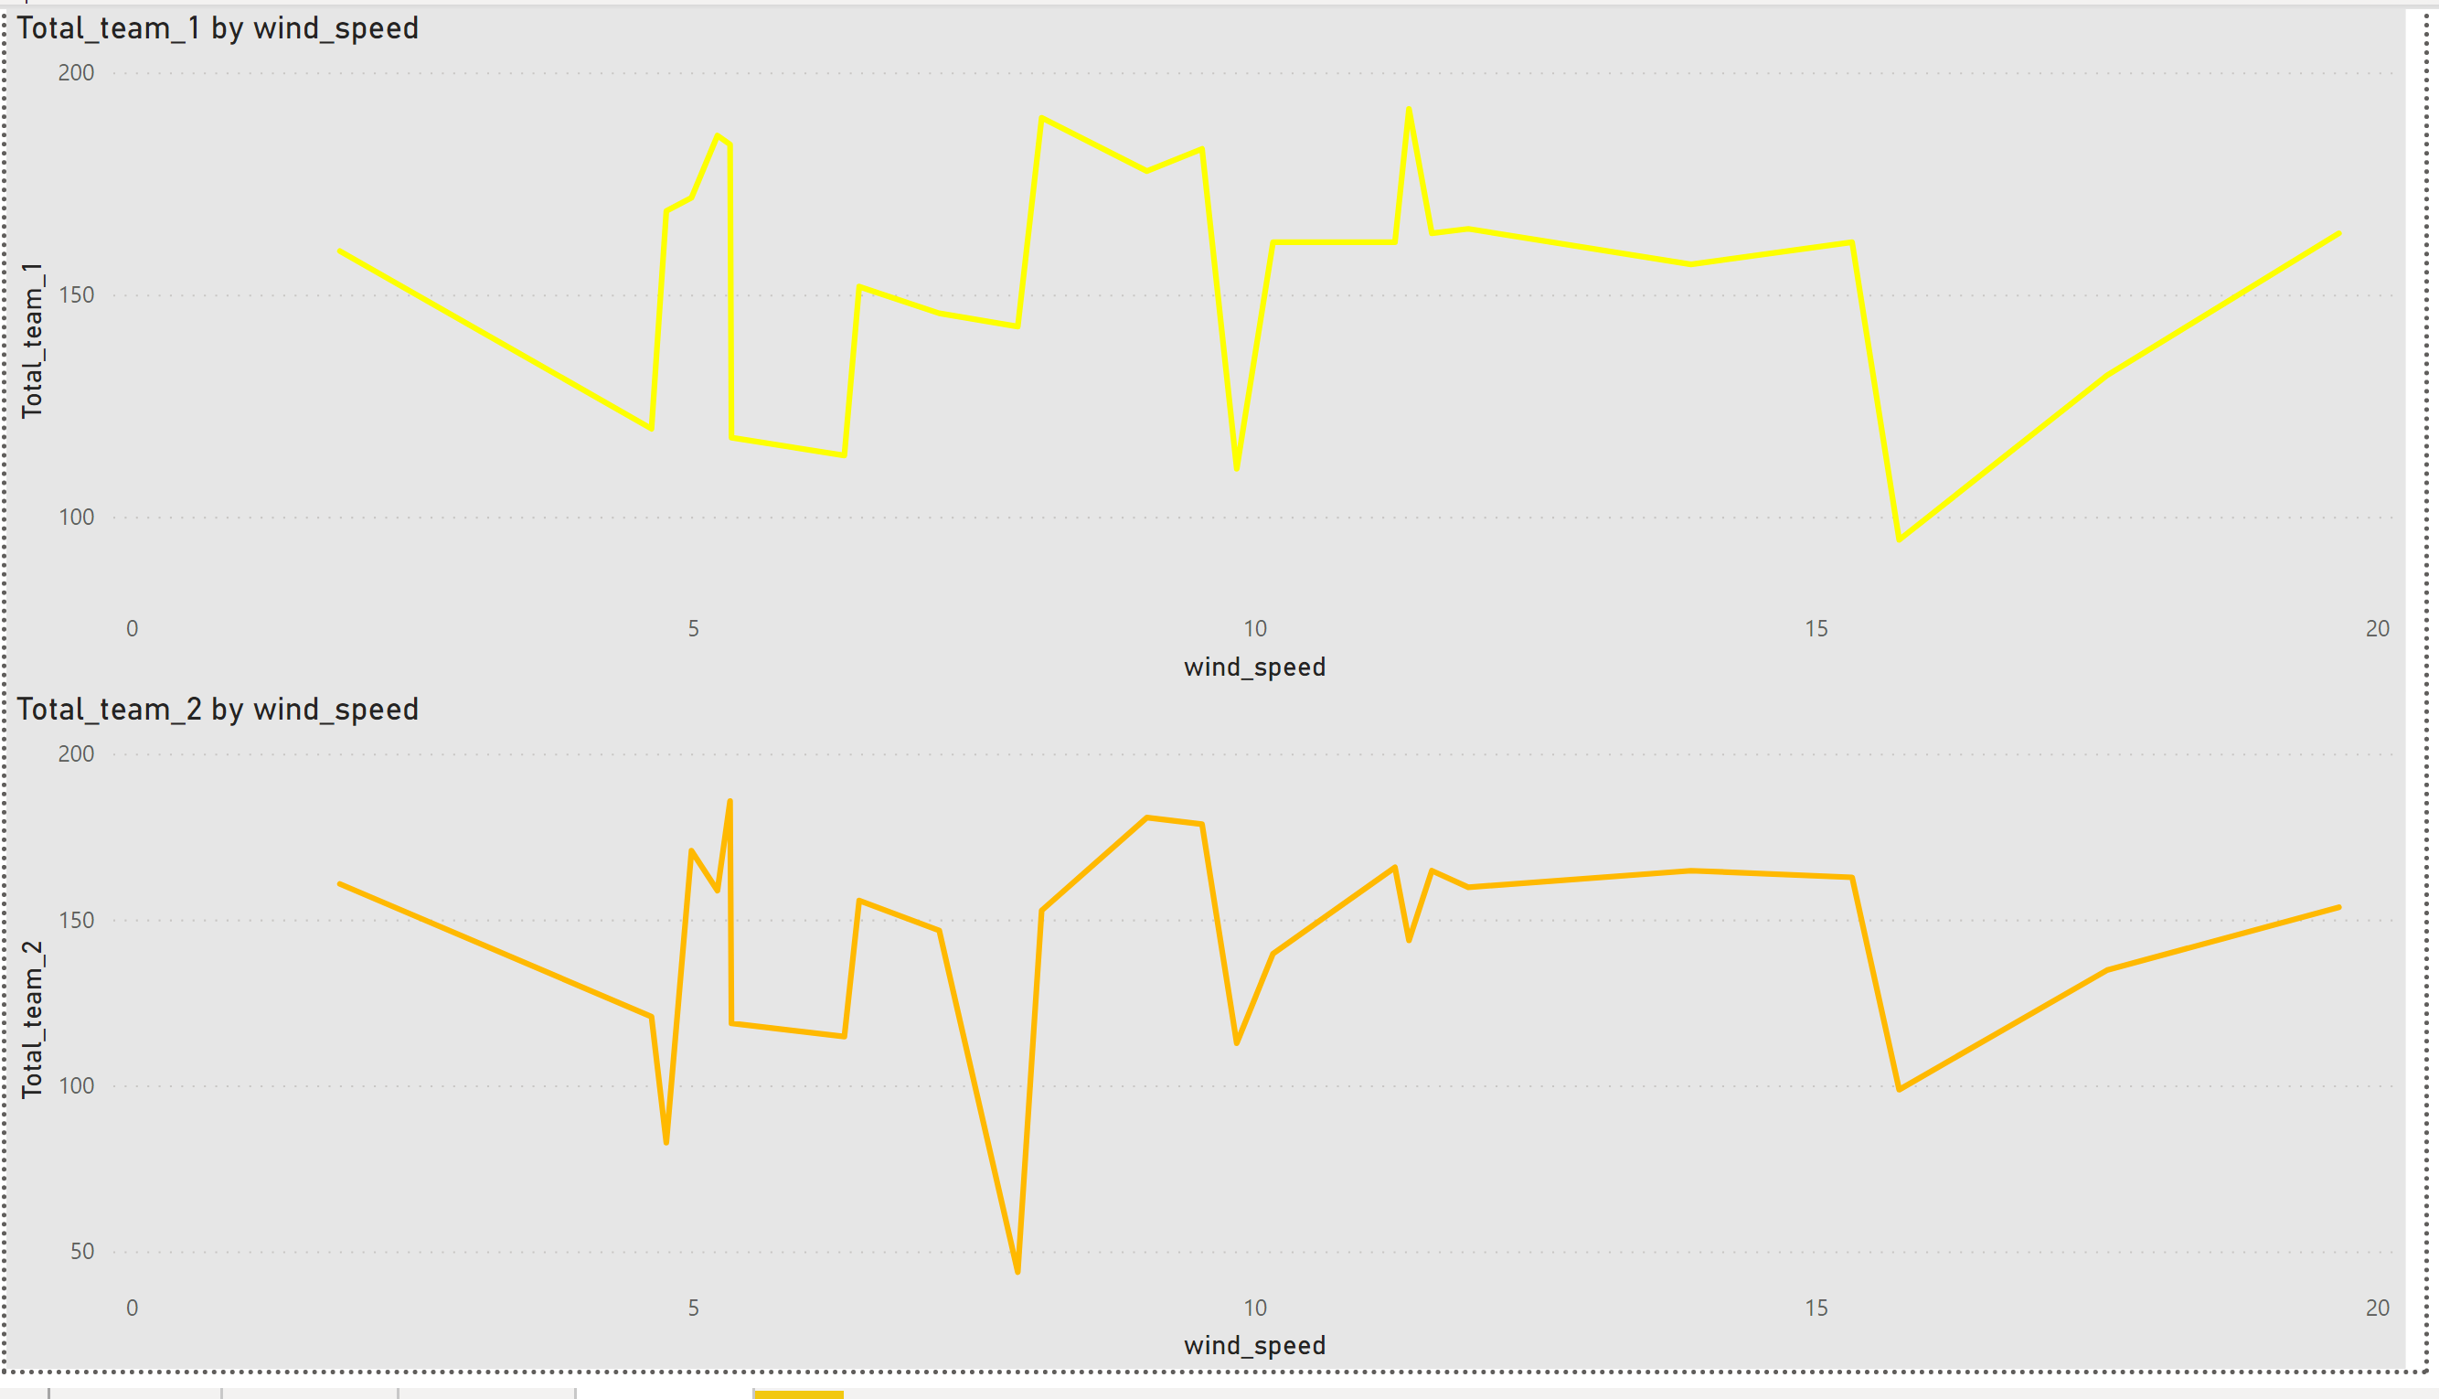

# References

[1] IPL dataset: <https://www.kaggle.com/raghu07/ipl-data-till-2017?select=Match.csv>

[2] Weather Dataset: <https://www.kaggle.com/sumanthvrao/daily-climate-time-series-data>

[3] <https://pypi.org/project/pandas/>

[4] <https://powerbi.microsoft.com/en-us/learning/>

[5] <https://www.w3schools.com/sql/>

[6] Basic Info About Cricket Game: https://en.wikipedia.org/wiki/Indian_Premier_League